MULTILINGUAL PROFESSIONAL WITH EXPERIENCE IN CUSTOMER SERVICE, FOOD AND BEVERAGE, SALES AND ADMINISTRATION.

HELLO
MY NAME IS KENNETH MWANGI Born 32 years ago in the great city of Nairobi, Kenya. I have 2 kids and 1 wife and I’m a catholic.
Been in Dubai for the past 8 years. An ardent lover of travelling an experiencing new cultures.

I speak 4 languages (English Included). Customer care professional ,Administrator , sales agent and a food and beverage specialist.

Kenneth
Kenneth.371087@2freemail.com

PROFESSIONAL EXPERIENCE.

BURJ AL ARAB HOTEL 2010 – To Date

Restaurant Reservations Department

POSITION: Food And Beverage Administrator
Accomplished Mission:

- Run day to day business in ensuring all the restaurants are full to capacity.
- Receive calls and email requests for different dining requests. Responding to them promptly and ensuring guests receive a smooth access to the hotel.

- Ensure that all guests request prior, during and after their dining experience are responded to and accomplished as per brand standard.

- Create new ideas to increase sales and revenue to achieve the monthly budget in all restaurants.

- Train the new colleagues and make sure they are able to deliver the set standards to our customers.

- Compile a daily report of all restaurants and rooms and deliver to the hotel manager.

Al Muntaha “Sky view” Restaurant and Bar POSITION: Senior Waiter
Accomplished Mission

- Leading the team in giving guests a smiling enthusiastic welcome
- Assisting the Manager and assistant manager in training of new staff and leading a team of qualified professionals that give the guest the best service in the world.

- Giving service to the 7 star standard of the hotel.
- Ensuring all orders are correct and on time
- Cashiering and reports to the restaurant manager
- Meeting and exceeding guests expectations and creating an ultimate experience for them.

- Handling guest complain and ensuring their satisfaction.

OBJECTIVE:

Seeking a challenging position in aviation, hospitality, customer care, real estate and guests services operation with an internationally known brand. A place where I can fully utilize and deliver growth to the organization using my knowledge ,skills and experience.

PERSONAL COMPETENCIES:

A flexible and skilled customer service administrator. A professional with first class experience in improving and developing sales. Excellent time management and adaptive skills

An able and determined leader with outstanding communication, negotiation and people management skills.

With diligence, extra determination to achieve or exceed set goals. Make everything possible to achieve workable environment for myself colleagues and my employers.

A very good team player and great thinker.

LINGUISTIC ABILITY:
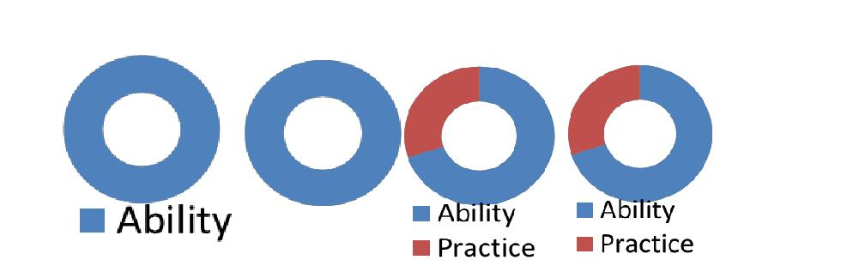

English Swahili Russian Spanish

INTERESTS

Reading Novels

Traveling

Playing soccer

Swimming

CALIFORNIA PIZZA KITCHEN- DUBAI MALL.- 2009 POSITION: Bar Team leader and Trainer
Accomplished Mission

- Construction of soft drinks, as per the recipe and the standard.
- Inspiring bar staff to deliver prompt, friendly and efficient service at all times.
- Providing day-to-day support to the restaurant managers.
- Daily Stock Control and full weekly audit. .
- Responsible for management of brand standards, stock rotation & cashing up.

PANAFRIC HOTEL. 2008
POSITION: Assistant Bar and Banqueting Manager

- Giving service to the brand standard.
- Managing a team of permanent and also casual bar staff & supervisors.
- Organizing the daily schedule and duties.
- Analyzing data and drawing conclusions for the business.
- Welcoming, guest and attending to their needs promptly.
- Constructing drinks as per the rules and regulation which govern the cold, hot beverages and all wines.

UTALII HOTEL 2007
POSITION: Assistant bar and banqueting manager

- Working with the Hospitality Manager in coordinating & planning for big events.
- Daily and weekly reconciliation of sales/ end of week/ payroll.

POPOTE WIRELESS: 2006
POSITION: Sales and Marketing Executive.

Advertising and promotion of the popote wireless phones.

NASCOP: 2005
POSITION: Data entry and analysis officer.
Accomplished duties:

- Taking records and keeping them in their respective files.
- Giving the correct analysis on the data profiles.
- Construction of data analysis and statistics work, through {PIM) matrix

EDUCATIONAL BACKGROUND.

KENYA UTALI COLLEGE.

•

•

Diploma in Food and Beverage management.
Diploma in Customer Services and customer care.

ADDITIONAL COMPETENCIES

- Epicure restaurant management systems
- First step to leadership
- Train the trainer
- Be the difference
- Hazard Analysis Critical Control Point
- Creating Ultimate Experiences
- Microsoft office, Words, excel, Power point.
- Oracle
- Counseling and guidance in H.I.V and Drug abuse.

REFEREES:
To be availed upon the request.

