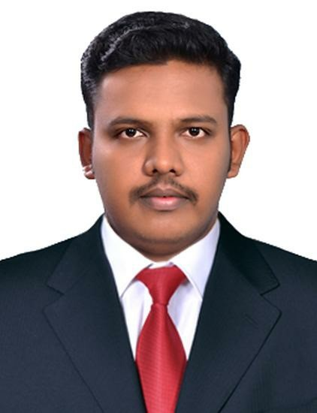
Adarsh
Adarsh.371091@2freemail.com
MECHANICAL ENGINEER

Summary
I completed B.E and Diploma in Mechanical Engineering. Now am looking for job related to field of study as Assistant Engineer for a long-term commitment. To work efficiently and effectively, as well as to build my career in a prestigious organization like yours that will provide me exciting opportunities to learn more and help me to explore myself fully and realize my potential and to become a successful professional.

Work experience

2 Year Experience. Workshop In charge

Concept Bikes (April 2015 - April 2017)
Worked as Workshop in Charge in an Automotive dealership for the last 2 years. Resigned to explore the engineering field for better opportunities and remuneration to build myself and learn new techniques and innovate something new.

My responsibility

- Maintenance of workshop and service vehicle
- Inspection of vehicle after work done
- Manpower handling
- Job allocation according to the nature of work.
- Process controlling
- Final Quality Inspection for delivery
- Preparing reports

Strength

- Creative and logical
- Problem solving ability
- Co-operative and keen observe
- I'm self-confident and can mould myself to all work environments
- Can work systematically and efficiently as part of a team and even as an individual.
- Hardworking mentality who believes in team work and very much conscious about time management and quality of the work.
- Flexible enough to fit into any kind of work environment and can handle any sort of stress and pressure situations up to the satisfaction.
Education

2011 – 2014 B.E Mechanical Engineering with 68% from Udaya School of Engineering, Nagercoil, affiliated under Anna University, Chennai, Tamil Nadu.

2008 – 2011 Diploma in Mechanical Engineering with 76% from Surya Polytechnic College, Nagercoil, affiliated under Directorate of Technical Education (DOTE), Chennai, Tamil Nadu.

2006 – 2008 +2 Biology Science passed with 58% from S.N.V.Govt.H.S.S, Kadakkavoor, under State syllabus of Kerala.

March 2013 Participated in National Level Symposium conducted by JNTU college of Engineering, Anantapur, Andhra Pradesh 2013.

Projects During my Diploma studies we done a project about the Fabrication and Testing of Nano Composite Materials in 2011.

During my B.E studies we done a project that Development and Analysis the Impact and Hardness Properties of Natural Fibres in 2014.
Skill

- MS Word
- MS PowerPoint
- MS Excel
- Outlook
- AutoCAD
- Supervisory
- Team leader

Field of Interest

- Oil and Gas
- Mining
- Assembly
- Maintenance
- Production
- Manufacturing
- Quality control
- Design

Languages Known

- English
- Malayalam
- Tamil
- Hindi

Hobbies

- Swimming
- Songs hearing
- Bike riding
- Watching movies
- Reading adventures and comic books

Declaration

I hereby declare that the statements and information furnished above are correct to the best of my knowledge. I assure you that I shall discharge my duties to the complete satisfaction of my superiors and devote myself wholeheartedly for the welfare of the company and add a feather to the cap of the company, if granted a chance.

