SHAHEER
Mechanical Engineer

SHAHEER.371092@2freemail.com
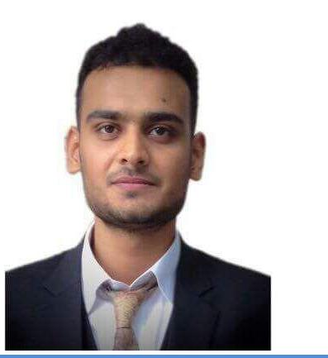

A M B I T I O N

Seeking the position as a Mechanical engineer in the field of aviation, Marine, Engineering & manufacturing, where my knowledge creativity & personal skills can be employed and developed.

Q U A L I F I C A T I O N

Heriott-Watt University, Dubai
Degree Bachelors in Mechanical Engineering

Pakistan Islamia Higher Secondary School, Sharjah
Degree Computer Science

Young Scholar Secondary School Khanewal, Pakistan
Degree Science

E X P E R I E N C E

- Atlas Copco
Marketing Engineer (01 June 2015 – 11 Dec

2015)

My job is to introduce the newly built oxygen and nitrogen air compressors in the market and encouraging them to use Atlas Copco compressors and doing survey's of companies and reporting weekly to my senior.

- Super Car Auto Accessories L.L.C

Auto Upholster (03 Oct 2012 – 01 March 2015)

During my under graduate studies I worked in Super car as a part timer. While working in Super car I had learned lots of things like Dashboard Upholstery , Body kit fixing, Car Tinting , Auto Accessories fixing and Interior Designing of cars i-e (Changing the fabric into Leather or changing the interior design of Cars).

- Al- Fayrozah Al- Zarqa Auto Accessories L.L.C

Auto Upholster (15 May 2010 – 01 July 2012)

I started my work as a beginner and my job is to help my seniors and to provide them the tools and helping materials. After sometime when I was able to work myself, then I was responsible to repair damaged seat of almost all type of cars and broken airbags and Car Headliners.

C O M P U T E R P R O F I C I E N C Y

- Experience in spread sheets, Power point and Microsoft Office,
- CREO
- C and C++ Programming
- HTML and CSS
- MATLAB

F I N A L P R O J E C T

2D Aluminium Frame

Proposed a Playground Design for “Engineers without Borders” Organization.
Manual Robotic Arm
Designing a Hydro Power Plant (Group Project)

H O B B I E S

- Working on different software

- Social work

- Teaching

- Islamic study

- Reading Books & Novels

L A N G U A G E S

- English............Fluent
- Urdu................Fluent
- Arabic.............Basic

M I S C E L L A N E O U S

- Possess U.A.E driving license with own Car

