SIRAJUDHEEN
Electrical Engineer
SIRAJUDHEEN.371095@2freemail.com
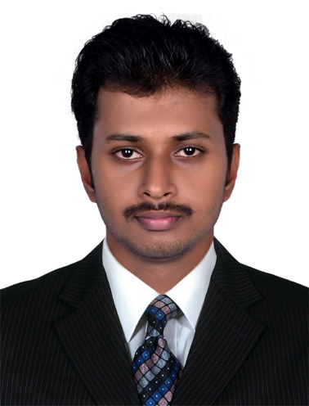
Personal  Date Of Birth: 15 March 1992  Sex: Male  Marital status: Single  Religion: Islam  Nationality: Indian  Language Known: English,  Hindi,  Malayalam,  Tamil.  License: Indian License | To work with a reputed firm to gain relevant experience and expertise to enable myself to deliver the company with what it expects from me, and at the same time to achieve the pinnacles of my goals by utilizing my talent in field of electrical and electronics engineering.  Educational Qualification
- B. Tech ( Electrical And Electronics Engineering- First Class)
(MG University – May 2014 )

Software Awareness

- Revit. MEP
- Proficiency in entire Auto Cad, Electrical Cad, & MS-Office
- Well versed in Windows
- Good understanding of Internet tools

Professional Skills

- Electrical installation, Operation & Maintenace and Testing & commissioning
- System trouble shooting and Control Wiring
- BOQ, Quantity estimation and engineering.
- Site installation supervision.
- Coordinating with Consultant/Subcontractors.

Personal Qualities

- Desire to work with cutting edge technologies and solve new technical challenges.
- I consider myself a fast learner and a team player.
- Having good communication skills, dedication to work.
- Man Power Management and Work Division
Work Experience - 3 Years

- Electrical Engineer
(Operation and Maintenance of Substation)
Duration : April 2016 – July 2017
Company : Kerala State Electricity Board Limited

Roles and Responsibilities:

- Over all Supervision of the Substation and Audit the Power consumed in the Substation.
- Scheduling and coordinating of various Shut down activities.
- Emergency and routine maintenance works carried out on the indoor switch gears and yard equipments like 12.5MVA 110/11kV Power Transformers, Control panels, Circuit breakers (SF6, VCB), Capacitor bank, Protective relays, Isolators etc.
- Issuing Isolation Certificate(IC), Non Back feeding Certificate (NBC) on various feeders to authorized personals.
- Issuing permit to work on HT lines to distribution section engineers under self responsibility.
- Checking schematic drawing of HV/LV Control Panels, Gas filling of SF6 Circuit Breaker and its trouble shooting.
- Monitoring the station battery charger and hence providing constant DC voltage for proper function of relays and connected controlling equipments.
- Well experienced in the Operation and Maintenance of all types of Circuit Breakers such as SF6, Vacuum also experienced in the Operation and Maintenance of Power Transformers and Instrument Transformers.

- Graduate Engineer Trainee
(Maintenance and Testing of power equipment)
Duration : October 2014 – April 2016
Company : Kerala State Electricity Board Limited

Roles and Responsibilities:

- Testing of Power Transformer, Current Transformer and Potential Transformer.
- Testing of Protection Relays like Differential, Distance, Over current and Earth fault, REF Relays.
- Planning, scheduling, resource leveling, controlling resources, estimation of costs, earned value analysis, tracking progress and all perspectives of project planning and management.
- Trouble shooting of all Electrical circuits, control and protection circuits.
- Planning, Scheduling and carrying out the maintenance of various substation equipments.
- Installation, Quality Checking & Technical issue clearing of Power & Control Cables.
- Preparation of all electrical drawings related to substation using Auto CAD and Revit MEP
- Supervision of all types of electrical installations according to approved drawings with effective utilization of manpower, material, quality and safety standards and managing their inspections, until commissioning and hand over of the project.
Declaration

I hereby declare that all the details furnished above are true to the best of my knowledge and belief.

