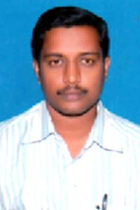
BIO-DATA

PERSONAL DETAILS:

Name : SHATHEESH
SHATHEESH.371098@2freemail.com
Date of Birth : 22-07-1980
Place of Birth : Madanapalle (Chittoor District)
Height : 5ft 6 Inches
Complexion : Medium
Religion : Hindu

Education Qualification :

Educational Qualifications : SSC

TECHNICAL QUALIFICATIONS:

- Diploma in Cell Phone Servicing
- Computer Hardware Engineering

EXPERIENCE :
Cell Phone Servicing all models in 8 years Experience in own shop

languages :
: hindi, English

