MOIZ.371134@2freemail.com 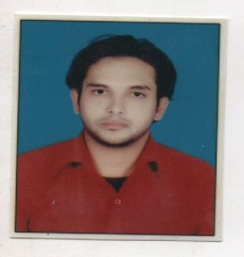

RESUME

MOIZ

CAREER OBJECTIVE

To learn and function effectively in an organization and seek a position to utilize my skills and abilities that offers professional growth while being resourceful, innovative and flexible.

STRENGTHS

- Good communication, motivational and leadership skills.
- Positive attitude and Target oriented.
- Confident and quick learner.
- Hard working.

ACADEMIC PROFILE

- B.Sc (PCM): Chatrapati Shahu Ji Maharaj University.
- Intermediate: MNR Junior College.
- SSC: Kama Reddy High School.

EXPERIENCE

- Customer Relation Officer having experience of 2 years in Hinduja Global Solutions.
- Pre-process Trainer having experience of 1 year in Hinduja Global Solutions.
- Coordinator having experience of 2 year in Rabsa Utility Solution Pvt Ltd.
- Supervisor having experience of 6 months in J.H web Solution.

SOFTWARE SKILLS

- Programming Languages: C
- Operating systems : MS Windows 98, XP
- Packages :MS-Office
- Web designing

LEISURE INTEREST

- Listening Music
- Surfing net
- Sports

PERSONAL INFORMATION

GENDER : Male
DATE OF BIRTH : 10 April,1985
RELIGION : Muslim
MARITAL STATUS : Single
NATIONALITY : Indian
LANGUAGES KNOWN : English, Hindi, Urdu & Telugu

DECLARATION

I do hereby declare that the particulars of information and facts stated here in above are true, correct and complete to the best of my knowledge.

