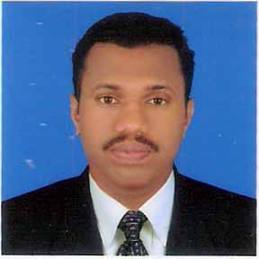
CURRICULAM VITAE

Asharaf

Asharaf.371145@2freemail.com

Objective

To become part of a successful organization by offering my services according to my good work experience and best abilities.
Name : Asharaf
Nationality : Indian
Age & Date of birth : 36 years, 02.02.1981
Qualification : PDC(+2) ,( Calicut university)
: SSLC (Secondary School Leaving Certificate)
Govt of Kerala

Working Experience : 2002 October to 2006 August.
MFC shipping co FZE Jebel ali .Dubai.
Position: Labour and Messenger.

: 2009 June to 2013May
Tony Roma’s Restaurant-Dubai
Position: Food delivery cum Driver

: 2013 June to Present
Trucktec International LLC Fze Jebel Ali
Position: Bus Driver and warehouse asst.

Languages Knows : English, Hindi, Arabic and Malayalam

License Details
Category : Motorcycle & Light Vehicle & Light Bus and
Heavy Bus (1, 3 ,5,6)
Issued From : Dubai
Date of Expiry : 25/07/2023
Declaration
I hereby declare that the above given information are true to best of my knowledge .

