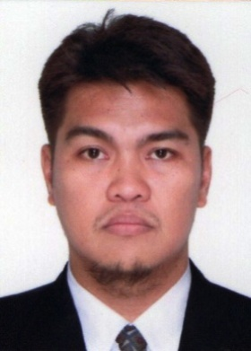

Darius.371149@2freemail.com

Darius

QUALIFICATION

NEBOSH International General Certificate in Occupational Health and Safety

SEMINAR AND TRAINING

Chicago Training and Consultancy Center, Abu Dhabi, UAE
NEBOSH IGC Occupational Health and Safety
- October 2016 – 02 December 2016

Technical Education and Skills Development Authority (TESDA)
Computer Hardware and Software Installation Training
Lucena Manpower Skills Training Center,
Lucena City, Quezon, Philippines
December 28, 2007

PERSONAL DATA
Age: 37
Birthday: April 7, 1980
Civil Status: Married
Height : 172.76 cm
Weight: 81 kg.
Nationality: Filipino
Religion: Roman Catholic

WORK EXPERIENCE

Admin Aide VI – Provincial Videographer/Editor
- to 2016 Provincial Government of Quezon

Work as part of the correspondence team that covers news, feature and documentaries of Quezon.
Edit and create short video clips that will be used in Quezon’s materials, website and social media channels

Computer Technician / Graphic Artist 2008 to 2010
SKILLS
Proficient in Photo and Video Editing with Adobe Photoshop and Sony Vegas.
PC Troubleshooting – Hardware and Software Installation.
Basic Photography and Videography.
Photographic Silkscreen Printing.

Tahonsky Internet Café, Lucena City, Philippines

Perform repair and installation of hardware peripherals and software for desktop and laptop computers.
Design computer graphic layouts for poster, logo and t-shirt silkscreen printing; perform editing for videos, photos and audio.

EDUCATION

BS Fine Arts
(Major in Advertising)
Manuel S. Enverga University Foundation
Lucena City, Philippines
2000

Computer Technician
Technical Education and Skills Development Authority (TESDA)
Lucena City Philippines
Sept. 2007 - Dec 2007

