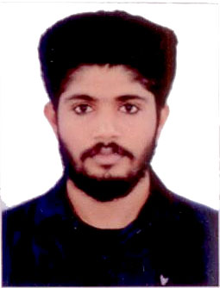
TASLIM

Taslim.371150@2freemail.com

PROFESSIONAL OVERVIEW

I am looking forward for an exciting career opportunity to work in highly professional and creative environment of a reputed organization, to prove and improve my skills along with a team and individually, where I can find all my efforts and time being utilized productively.

PROFESSIONAL EXPERIENCE

- VERTEX MULTI NATIONAL CO.
Position: Customer Solution Executive

HIGHLIGHTS

- Solid Customer Service Experience
- Outstanding Written and Oral Communication Skill in English.
- Professional Team Member.
- Better Leadership Quality.
- Result Oriented.

ACADEMIC QUALIFICATION

- S.S.L.C under the Board of Public Examinations Kerala (March 2008)
- +2 under the Board of Vocational Higher Secondary Education (March 2010)
- ITI In Electronics Under The Board Of NCVT(April 2013)

COMPUTER SKILLS
- Photoshop
- MS Office
- Advanced concept of Information Technology, Internet & E-mail.

OBJECTIVE SKILLS

  - Ability to work in a busy and challenging environment.
  - Willing to take initiative.
  - Processing good leadership and interpersonal skills.
  - Self confident, with positive outlook & professional attitude.
  - Mature personality and sound physique.

PERSONAL DETAILS

- Nationality : Indian
- Sex : Male
- Marital Status : Single
- Languages Known : English, Hindi, Malayalam (Expert to read, write and speak)
Arabic (able to read)
DECLARATION

I hereby declare that the above given facts are true to the best of my knowledge and I bear responsibility for the correctness of the details.

Place: SHARJAH TASLIM

