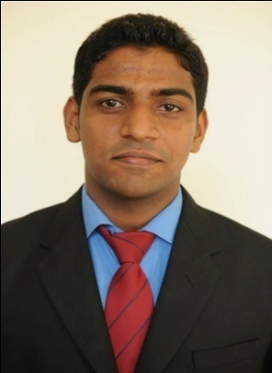
MOHIYUDDIN
MOHIYUDDIN.371151@2freemail.com

OBJECTIVE:
Seeking a quality environment where my knowledge & experience can be shared and enriched. Looking for an opportunity to contribute my professional qualities, technical skills and experience for the organization.

PROFILE IN BRIEF:
- Hold Master Degree MBA in Finance & Marketing.
- Hold KSA Drivers License.
- Overall 2 years of Experience as a Accountant.
- Excellent verbal & written communication skills & Customer Service Skills.
- Have excellent communication skills in English and can effectively handle clients, contractors, consultants.
- Excellent communication and inter personal skills.
- Ability to work under pressure to handle multiple tasks, committed to manage and meet deadlines.
- A quick learner, precise, self-motivated and hard working.

WORK HISTORY:

- Worked with M/S GULF CREW TRADING & CONT. CO. (GCT) Dammam, KSA as a Accountant ( June 2015 to Nov 2016 )
- Prepare, examine, and analyze accounting records, financial statements, and other financial reports to assess accuracy, completeness, and conformance to reporting and procedural standards.
- Preparing accounts, Processing of customer payments and balancing accounts.
- Administering payrolls and controlling income and expenditure
- Auditing financial information
- Compiling and presenting reports, budgets, business plans, commentaries and financial statements. . Entering vendor invoices into the system and communicating with vendors.
- Analysing accounts and business plans
- Financial forecasting and risk analysis
Meeting and interviewing clients
- Managing colleagues, workloads and deadlines
- Prepares asset, liability, and capital account entries.
- Worked with M/S Prithvi Developers Mangalore INDIA as a ASST. ACCOUNTANT Mangalore, INDIA ( May 2014 to May 2015 )

Job Description:

- Real estate accountants prepare financial material for property management organizations.
- Accounting records and draft reports to help real estate managers develop and handle their budgets.
- Prepare or contribute to documents such as lease and rental agreements, cost estimates and annual reports.
- Calculate tax liabilities and prepare tax returns on behalf of real estate organizations.

ACADEMIC & TECHNICAL PROFILE:

- MBA (Finance & Marketing) in St. Aloysius Institute of Management and Information Technology, Mangalore India.

- Computer Skills: MS-Office, TALLY ERP-9, express Internet, Software exposure.

ACADEMIC PROJECT AND INTERNSHIP:

- A project Report on “STUDY ON THE PROBLEM OF COMPARTMENTALIZATION at FASHION BIG BAZAAR IN MANGALORE ( 12 WEEKS)
- Summer Internship Project at HERO MOTORCORP Company, Puttur (June and July 2013).
- Organizer of National level management fest insignia 2013,2014
- Committee member of National level fest INSIGNIA 2013-14
SPECIALISED TRAINING:

- SPSS (statistical Package for Social Science)
- Good knowledge on Microsoft office

DECLARATION:
I hereby confirm that the information given above is true to best of my knowledge.
Place: Dubai, UAE.

