CURRICULUM VITAE

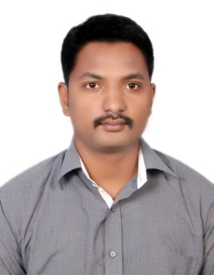
VENKATA
VENKATA.371158@2freemail.com
__________________________________________________________________

Objective:

Looking for an opportunity in an esteemed organization to enhance and enrich my skills in state – of – art technologies and also to inspire myself as per the needs of the Organization.

Personal Skills:

Comprehensive problem solving abilities, excellent verbal and written communication skills, Honesty, ability to communicate clearly and effectively in many mediums: by email, verbally, with lists and phone messages, on the phone, and with body language. Communication also includes listening skills and the ability to follow directions and provide feedback.

Educational Qualification:
- D.C.M.E - Diploma in Computer Science, Mukteswaram, Est. Godavari Dist.
- S.S.C. – ST’ANNS English Medium School Macherla, Guntur Dist.

Technical Skills:

Operating System : MS-DOS, Windows 98 – Windows 8
Packages : MS-Office – 98 – office 365,
Languages : C, C++, DS – C, VB, JAVA, Oracle, Html.
Hard ware : Computer assembling and maintenance,
Troubleshooting hardware and software problems, Installing and configuring the peripherals, and drivers, Deep knowledge of printer and cartage refilling. Networking and telecommunications.
Experience :
- Two years as computer operator in MDO Office Macherla.
- One year as a BRANCH MANAGER in WELLFARE BUILDINGS & ESTATES Macherla.
- Two years as Equity Dealer in ANGEL BROKINGS at Macherla.
- One year as a Sales manager in Hindustan uniliver at Macherla.
- At Present working as Junior Assistant at Proh. & Excise Station, Macherla.
From 11-12-2013.

Personal Details:

Date of Birth : 18-01-1989

Sex : Male

Nationality : Indian

Marital Status : Married

Declaration:

I hereby declare that all the information provided is true to the best of my knowledge and belief.

