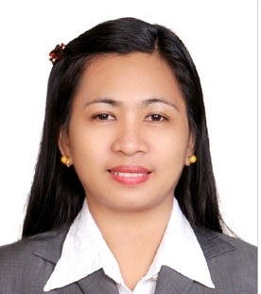
Sylvia
Sylvia.371161@2freemail.com
_________________________________________________________________________________

Position Applied : PHARMACIST / ASSISTANT PHARMACIST/ OTHER RELATED JOB

Objective : Seeking a challenging job and better opportunity to render my
good quality service with my knowledge and skills to the company

Skills and Qualifications : With more than 2 years of working experience as Community Trainee
Pharmacist
: With more than 3 years of working experience as Assistant
Pharmacist
: Operating Computer ( Microsoft Word and Excel)
: Hardworking, ability to work under pressure, honest and trustworthy

Employment :
TRAINEE PHARMACIST

Eswagenerics Pharmacy (October 28, 2014- Dec 02, 2016)
San Fabian, Pangasinan, 2433 Philippines

Main Duties :

- Dispense Medicines as written on the prescription prescribe by Physicians and Dentist.
- Perform Patient Counseling (guiding them on how to take the prescribe medicines).
- Record and safe keep the received prescriptions.
- New store personnel trainer and educating them regarding the products being sold on the Pharmacy.
- Educate store personnel on FDA laws, Pharmacy laws, memoranda, and other laws related to dispensing of medicines and keeps a file of the said documents.
- Observes all customers complaints and giving customers information on the products.
- Perform product inventory and check-submit near expiry or expired products.
- Checking and updating license to operate, business permit and other documents related to drugstore operation.
- Kept updated books like USP, RPS, MIMS, PIMS, Toxicology and other reading materials.

Employment History:
ASSISTANT PHARMACIST
RosPearl Drugstore (Feb 01, 2011- Mar 21, 2014)
San Fabian, Pangasinan, 2433 Philippines

Main Duties :
- Perform Patient Counseling (guiding them on how to take the prescribe medicines).
- Observes all customers complaints and giving customers information on our products.
- Perform product inventory and check-submit near expiry or expired products.
- Maintain clean and order in the Pharmacy and products being sold in the pharmacy.
- Take notes and report to the owner the products not available in the store but frequently asked by customers.
- Record Senior Citizen Purchases. Maintain clean and order in the Pharmacy and products being sold in Pharmacy.
- Prepare relevant paper reports and performs other related functions assigned.

Education
BACHELOR OF SCIENCE IN PHARMACY (B.S. Pharm)

Year Graduated: April 11, 2008
Virgen Milagrosa University Foundation

Personal Information:
Marital Status : Married
Nationality : Filipino
Age : 33
Height : 5'4"
Number of Child : One Son 11 yrs old;
: Two Daughters 3 yrs old and 1 year old.
Visa Status : Visit Visa

