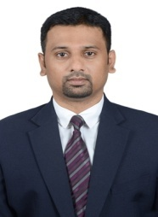
a
SYED
SYED.371162@2freemail.com

JOB OBJECTIVE

Scaling new heights of success with hard work & dedication and leaving a mark of excellence on each step; aiming for senior level assignments in Admin. / Facility Management / Personal Secretary to Directors with a leading organization of repute

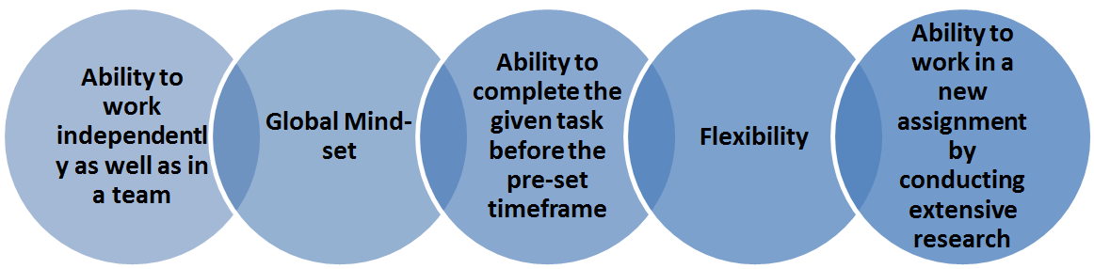

PROFILE SUMMARY

- Dynamic career of 14 years that reflects pioneering experience and year-on-year success in Facilities Management, Secretarial Operations and Administration (broadly covering human resources, information systems, logistics, purchasing, vendor management, accounting, finance, legal, statutory obligation, payroll processing, tax planning, inventory control and student / customer services)

Enterprising leader with a solid record of contributions that developed & streamlined the core skills of all administration & facility functions, invigorated businesses, heightened productivity & enhanced internal controls

Demonstrated excellence in handling end-to-end secretarial operations (to Directors):

Fixing appointments & meetings and developing synopsis of reports & presentations received from Directors; handling budget to control administration expense & minimize operational cost

Adept in providing secretarial support involving handling top & confidential correspondence and document flow, screening telephone calls, attending visitors and directing various queries to relevant departments

Proficient in managing Facility Management Services involving:

Handling the procurement of materials, machinery & office equipment; ensuring correct forecasting of supplies to maintain optimum inventory and developing & maintaining cordial relations with vendor base to get competitive rate

Developing budgets & annual plans to manage facilities as per organizational needs, managing inventory of materials and handling procurement of same in desired timeframe

Selection & finalization process of outsourced agencies and providing various services in facilities like Housekeeping, Cafeteria, Security, Landscaping, Transport, Pest Control, etc.

Skilled in handling a wide spectrum of administrative activities including material procurement, vendor development, housekeeping, budgetary control, security management and outsourced annual service contracts

Gained working knowledge of import, custom clearance & purchase works from abroad (specially China)

Directed cross-functional teams using interactive and motivational leadership; acknowledged for recruiting & mentoring leaders with an equal desire to win

Proven ability to telecommute & maintain high productivity & visibility while outside of office; appreciated for same

Responsible person for the companies critical decisions and growth during the absence of the Directors.

Entire bank operations is been solely handled.

Core functional strengths include:

Strategy Planning

Change Management

Analysis & Insights Leadership

Performance Improvement

Risk Assessment & Management

Multiple Project Management
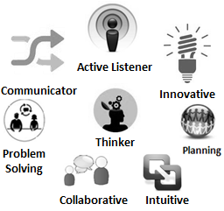
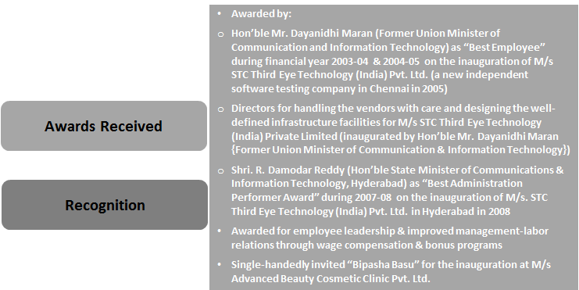
Soft Skills Career Highlights

ORGANISATIONAL EXPERIENCE
Since May’03 STC Group of Companies, Chennai as Head-Admin. & Facilities / Personal Secretary-Directors
(M/s STC Technologies Private Limited, M/s STC V Serve Private Limited, M/s STC Third Eye Technology (India) Private Limited, M/s Testing Jobz, M/s Prolabs, M/s A La Change, M/s Max Hair Studio International Pvt. Ltd., M/s Luxury Lifestyle Webstore International Pvt. Ltd. and M/s Advanced Beauty Cosmetic Clinic Pvt. Ltd.)
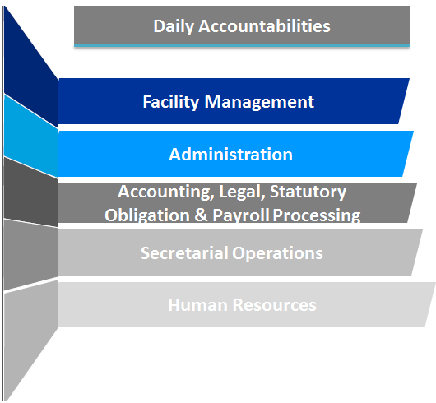
Role:
Facility Management:
- Preparing plans for facility operations
- Looking after visa process for countries like Singapore, Thailand, Malaysia, Dubai, Australia, UK, USA, China, Schengen & Canada
- Arranging travel arrangements (tour, cab, accommodation, flight & train–domestic & international) and liaison with Telephones & Electricity Board
- Working on activities related to Foreign Exchange
- Accountable for handling proper & sufficient infrastructure across the branches
- Facilitating & satisfying the needs of the employees
- Designing the performance appraisal system for the organization and welfare activities
- Convincing the senior management for importance of technology and handling the implementation of a fully networked & automated office
- Evaluating the systems, negotiating on terms with vendors, assisting in installation and providing systems support
- Working independently to determine methods and procedures for new assignments
- Leading a team of 25 members

Administration:
- Looking after all business transaction operations
- Verifying:
- Documents with respect to all business transactions
- Administrative reports like Collection & Expenses, Petty Expenses and Material Movements
- Company’s stationery store / Admin Store by monitoring min & max level of stationery / consumables items
- Handling & maintaining the fund management activities
- Verifying & approving all the expenses of the organization
- Developing & maintaining good relationships with:
- Branch offices & franchisee centers
- Government Officials like Income Tax, Service Tax, Labor & Regional Transport Officials and Foreign Clients
- Creating:
- Project Report and arranging the loans from financial institutions & banks like OD,Personal & Business Loans, Mortgage , Housing & Automobile (Car/ Two Wheeler /Commercial Vehicle) Loans for the Directors and companies
- Official Letters, Notices, Bonds, Agreements and Circulars
- Documents / legal agreements for international assignments
- Authorizing & issuing appointment letter and reliving documents and official documents
- Handling all aspects of the dedicated delivery operations for all separate locations of the companies with input throughout entire planning & implementation process; designing & introducing operating standards for each location
- Rendering exemplary standards of student service; resolving student claims, disputes & complaints
- Responsible for monitoring & handing attendance, leave & payroll management
- Interacting with Visitors, Bank Managers, Government Officials & Clients as per requirement and forwarding the same to the required concerned
- Liaising with bank officials for all major transactions

Accounting, Legal, Statutory Obligation & Payroll Processing:
- Creating:
- Financial statements and estimates of advance tax payable
- Return of income and its submission to Income Tax Officer
- Working as:
- Financial Consultant for future business development
- Authorized Person for preparation of Form16 (Salary) / Form16A (TDS Certificate) / filing of ETDS return
- Actively involved in possible tax planning with reference to existing activities of the companies
- Verifying the:
- Calculations for PF, ESI, TDS & Service Tax
- TDS return and its submission to TDS ward before 7th of every month
- Assuring that the:
- PF & ESI are paid within 12th or 13th of every month, Service Tax is paid before 5thof every month and ROC return to be filed annually
- Salary payable as per payroll is credited to the respective salary bank account of employees or paid through cheque or cash before 10th of every month
- Companies collections are properly deposited in bank (cash, card & cheque) & accounts are maintained properly
- Handling the required details of PF & ESI Consultant and managing tax deduction from the employee’s salary (after confirming with the auditors on the total tax liability of individual for the year)
- Liaising with International Attorneys like M/s.Surana & Surana & M/s. JUS Maxima Law Office, Mr. N. Raja Senthoor Pandian (Advocate) & Mr. Vijayalakshmi K. Rajaratnam (Advocate) for companies / directors legal issues
- Looking after all companies statutory obligation and legal issues
- Managing all the required documents & registers to the auditors for accounting into the system and discussing for finalization of accounts
- Accountable for due collection with clients and due payments to the vendors
- Formulating budget plans and balancing revenue & expenses without raising rates
- Overseeing the registrations with regards to STPI, NCVT (National Council for Vocational Training), Trade Mark, Copyright, Import & Export Code, Cosmetic, Professional Tax, Chennai Corporation Business License, Southern Railway Commercial Publicity Canvasser ship, TIN & CST No. and New Company Formation – India & USA
- Acquiring the Police Verification Certificate
- Authorizing for bills, payments, vouchers document and receipts
- Computing the incentives and PLB (Performance Linked Bonus) for the employees

Secretarial Operations:
- Attending & making calls to the Directors
- Looking after daily schedule / itinerary for the Director
- Getting an appointment with Higher Officials like Minister, Commissioner, Collector and Celebrities
- Drafting the important official and personal letters for Directors
- Maintaining the personal records of Directors
- Scheduling the financial and business activities of the Directors
- Filing the Income Tax returns of Directors

HRM:
- Actively involved in orientation of new employees
- Recruiting employees from operator to manager level and assisting V.P.-HR in higher level recruitment for all locations from corporate office

Highlights:
- Handled strategic & promotional activities for the organization
- Contributed in the successful set-up of interior & utilities for new offices and completed on or before given timeframe; played a pivotal role in finalization of layouts & setting-up of interiors in the office premises and maintaining a uniform design, colour scheme, choice of materials, so on
- Instituted a processes for each activity under Facility Management, thereby achieving remarkable scores in all audits on control
- Achieved space optimization and consolidation in the unit thereby delivering an annualized savings
- Disseminated a centralized budget for Facility Management in each unit / zone and instituted a mechanism to track expenses for driving efficiency; it resulted in savings against the annual Operating Expenditure (OPEX) budget
- Worked & coordinated with Design Works & Saran Associates for layout & interior, building elevation works and architectural works for new office set-ups & Director’s House

PREVIOUS / PART-TIME EXPERIENCE
Apr’02-Apr’03 Software Solutions Integrated Limited, Chennai as Operation Executive

EDUCATION

Pursuing MBA (Finance & Systems) from CDE-Bharathidasan University, Tiruchirappalli
2003 B.Sc. (Computer Science) from The New College, Chennai

Other Course:
- Master of Diploma in Advanced Information Technology from Bureau of Data Processing Systems Limited, Chennai in 2002

