BRINJITH
BRINJITH.371163@2freemail.com 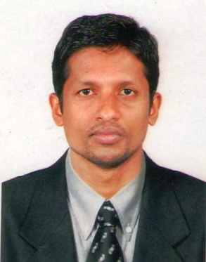

Career Objective
Creative Administrator/Accountant equipped with a broad knowledge and concepts and strategies to yield the best possible administrative and financial outcome.

Highlights
Analytical reasoning – Financial Statement Analysis – Effective Time Management – Excellent managerial techniques - Flexible team player - Strong organizational skills - Account reconciliation expert – Strength in regulatory reporting –complex problem solving –general ledger accounting .

Professonal experience
- Brinks Arya India pvt. Ltd,kerala (junior executive )10 june 2008 - 20 may 2009

- Roy & Associates Tax practioner,kerala (Auditing assistant) 1 july 2012 -5 june 2014

- Ignatius Varghese & Chartered Accountant,kerala (Auditing assistant) 10 June 2014 - 20 January 2016

- Kavalackal Distributors,Ernakulam(Accountant) 1 February 2016- June 2017

Administrative experiences
- Effective organizational skills
- Scheduling meetings and preparing agendas for them
- Scheduling and delegating administrative task
- Creating presentations and writing up reports
- Organizational travel and accommodation arrangements

Accounting experiences
- Facilitated month / year end close processes, invoicing ,journal entries and account reconciliation and finalization of accounts.
- Sales tax return filling ,income tax return filling
- Received ,recorded and banked cash ,cheques and vouchers as well as recon ciliated records of bank transactions.
- Managed daily stock report for quality assurance purposes
- Designed and created weekly and monthly spending report

Educational experiences
- MBA Finance
(Bharathiyar University)
- Bachelor of commerce (B.com)
(Calicut University)
- Tally Erp 9,Ms. Office ,ERP,Peachtree (ms.word,ms.excel,ms.powerpoint)

Project profile
A comparative study on inventory management for spinning Mills at Kerala Lakshmi Mills,Thrissur,Kerala.
Duration : 5 months (01-11-2010 to 30-04-2011)

Personal details
Date of birth : 23-12-1985
Sex : Male
Marital status : Single
Nationality : Indian
Languages know : English,Hindi,Malayalam, Tamil

Declaration

I hereby declare that the above mentioned details are true to the best of my knowledge

