Curriculum Vitae
OBJECTIVE
Muffadal
Muffadal.371191@2freemail.com
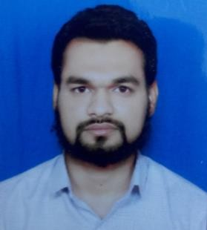
To achieve perfection in my work through the process of constant learning, hard work & vision combining with leadership contributing the best to the organization.
TECHNICAL QUALIFICATION :-

CCNA:-
From:- Jetking Infotrain Ltd., A.B. Road, Indore (MP)

JCHNE:-
(Jetking Certified Hardware & Networking Engineer) From:- Jetking Infotrain Ltd., A.B. Road, Indore (MP)

NIELET :-
Advance Diploma in computer Hardware maintenance and Networking ( CHM ‘A’ level )

Note -: I am on visit visa, my visa expired on 1 October 2017
TECHNICAL SKILLS:-

Operating System:-
Installation, Configuration and Maintaining these Operating Systems, Windows Server 2003,2008 & R2 ,2012
Windows Client (XP, Vista and and win.7 and win. 8. 8.1 win 10) Linux , Ubuntu , CentOS , Xen and Esxi

Working on All Windows Version Xp to Windows 10 :-

Managing Configuring and Troubleshooting, Local User, Groups, and Desktop Setting, Display Devices, Hard disk partition/Formatting.

Hardware:-

Assembling an Disassembling PC Maintaining & Identifying Problem of the System.

Application Software:-

MS-Office 2007,2010 ,2013, (Word, Excel, PowerPoint) & Installations of Drivers and Software’s, Cisco packet tracer , Team viewer , Ammyy admin , VMware workstation

Server:-
Configuration and maintaining LAN, Network, installing active directory, DNS, DHCP, FTP, TELNET, DFS, User profile, remote connectivity, assigning IP address, Managing local and domain user’s account and groups.

CCNA:-
IP addressing and Subnetting , Dynamic and static NAT configuration Routing protocol RIP,IGRP,EIGRP,BGP and OSPF Configuration, Switches configuration , Vlan , MAC filtering Telnet , Redistribution area , configuring of Juniper Firewall
Experience

Burhani Computers (August 2009 to 2013)
Company profile:- Maintain leads IT services and product distributer

Title:- System engineer

Role and Responsibility

My role as a Hardware & Network engineer

- Assembling & dissembling PCs
- Troubleshooting PC
- Printer and OS problem
- Outlook and other Network related connectivity problem in network side
- Installing CAT 5 and CAT 6 cabling And Design LAN network

IT–TECHCOM (July 2015 to June 2016)

Title:- Sr. Computer hardware & Network Engineer

