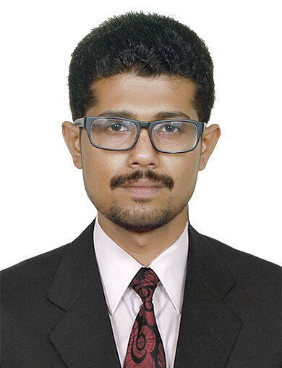
VIPIN

VIPIN.371192@2freemail.com
Mechanical Engineer

OBJECTIVES
To learn and function effectively in an organization and be able to deliver to the bottom-line. To constantly upgrade my knowledge and skills and make a difference in whatever I do.
PROFESSIONAL SUMMARY
- Worked as a Junior Mechanical Engineer at L&T VALVES Coimbatore, India, for 3 Year’s
RESPONSIBILITIES TAKEN
- Inspection of all Mechanical Equipments as preventive maintenance procedure and recording it.
- Maintenance and repair works of material handling equipments, cranes, Test stands etc.,
- Planning and execution of the manpower and work schedule.
- Taken responsibility for modification and rectification of problems in Valves whenever necessary.
- Perform/witness NDT (UT, PT, MT) and post-weld treatment (PWHT). Keeping records of NDT performed as per ASME V and client specification.
- Provide Welding recommendations, prepare of repair work scopes for static equipment and piping are fit-for-purpose and in line with expected standards including weld procedures and associated inspection plans.
- Maintained QA/QC activities related to Valves & Welding works.

EDUCATION
- Diploma in Mechanical Engineering
- Certification in PCN PT(Penetrant Test) PCN NO : 333061
- Certification in ASNT LEVEL II: NDE Certification as per American Society for Non Destructive Testing on-
- Dye Penetrant Testing (DPT)
- Ultrasonic Testing (UT)
- Magnetic Particle Testing (MPT)
- Radiographic Test (RT)

SKILL SET
- Communication skills.
- Self Motivation.
- Self Confidence.
- Hard and Smart Worker.
- Computer skills (Proficient in MS Office).
INTERNATIONAL CODES & STANDARDS
- ASME section B 16.34 for Valves

- ASME section V for NDT Examination

- ASME section IX for Welder Qualification & Procedures
- API 6D/ 600 Valve Standard
- API 598 Valve Testing

CAMPUS AND COMMUNITY ACTIVITIES
- Worked as Career Guidance assistance for the awareness of youth at Sri Ramakrishna Ashram-Coimbatore by Youth Red Cross.
- Worked as a coordinator for the arts fest and sports meet.
- Leadership as the post of Chairman of Mechanical Engineering Students Association.
- Worked as the post of President at Red Cross.
- Worked as a member for Rotract club.

PERSONAL DETAILS
Nationality : Indian
Gender : Male
Date of Birth : 15-06-1991
Visa Status : Tourist Visa (24th May 2017 – 22nd Aug 2017 )
Language Known : English, Tamil, Hindi and Malayalam
Marital Status : Single
DECLARATION

I do here by declare that the particulars of information and facts stated here in above are true and authentic.

