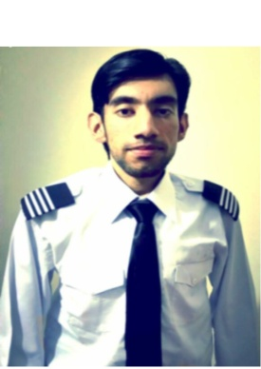
CURRICULUM VITAE

PERSONAL INFORMATION:

NAME: Syed
Syed.371207@2freemail.com

OBJECTIVE:
Seeking a position with a well established company where I can maximize my program development and training skills

QUALIFICATION:

DEGREE: (2013-2016) Aviation Management Degree from UMT Lahore, Pakistan
INTERMEDIATE: (2010-2012) Siit College from Sialkot, Pakistan
MATRIC: (2008-2010) Pakistan Higher Secondary School Sharjah, U.A.E

COMPUTER SKILLs:
Microsoft office (Excel, PowerPoint and Word)
Window 7, Window XP
Internet searcher
PowerPoint
Download and installation software in computer
LANGUAGES:
English – good written & spoken
Urdu-fluent written & spoken
Punjabi- fluent spoken

ONLINE COURSE:
Aircraft accident investigation from Embry Riddles Aeronautical
University (USA)

CERTIFICATION:
Aircraft accident investigation
1 week ground handling of Gerry’s Dnata
Event organizer certification
Travel Agency Internship

Other Skills:

- Communication
- Teamwork
- Problem solving
- Planning and Organizing
- Self-management
- Learning

WORK Experience:
8 Weeks Travel Agency experience

Job description:
I have booked the travel ticket and give the consumer to hard copy that he/she has to traveling at this specific time.

