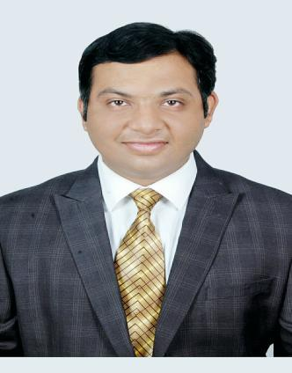
CURRICULUM VITAE

Dr.Sudhanwa
Sudhanwa.371227@2freemail.com

BDS, MDS, FPO

Specialist Pediatric Dentist & Pediatric Orthodontist

State Dental council Registration)

(Eligibility Letter as Specialist Pediatric Dentist by Dubai Health Authority dated 18/06/2017)

EDUCATION

B.D.S (2010) From Sharad Pawar Dental College ,Wardha (MUHS,Nashik)(M.S),India

National Assessment and Accreditation Council : Grade ‘A’

M.D.S(2013) in Pedodontics & Preventive Dentistry from Mamata Dental College & Hospital ,Khammam (A.P),India

National Assessment and Accreditation Council : Grade ‘A’

FPO(2016) Fellowship in Pediatric Orthodontics ,DMIMS University,Wardha(M.S),India

EXPERIENCE

Assistant Professor in Pediatric Dentistry in Sharad Pawar Dental College & Hospital ,Wardha (2013-2016)

Pediatric Dental Consultant in 20 different clinics across Vidarbha region of Maharashtra ,India (More than 3 years and 6 months)

PROFESSIONAL SKILLS

- Good communication and interpersonal skills

- Vast experience in diagnosing dental problems and conditions

- Management of uncooperative patients.

- Counseling as well as advising patients and family on growth development dental problems of patient.

- Providing preventive dental services through Application of Fluorides as well as Dental Sealants.

- Performing treatment for primary & permanent teeth like Extractions

- Restorations, Pulp therapy procedures & Root canal treatments using Rotary Instrumentation .*

- Post and Core Restorations using Fiber optic posts and Fiber reinforced

- Composites

- Placement of Primary teeth with Stainless Steel And Zirconia Crowns *

- Management of space and crowding problems using Space maintainers and myofunctional appliances suitable for growing arches.*

- Management of patients with Dental and Soft tissue Truma.

- Managing patients with behavioral problems Syndromic ,Phisically

- Disabled children, Bleeding disorders and Cardiac patients.

- Performing Minor oral surgical procedures using Conventional techniques and Lasers.*

- Performing treatment under Sedation and General Anesthesia*

- Doing Fixed Orthodontic cases (Minor Corrections & Non Extraction cases)*

- Knowledge of Nasoalveolar Moulding (NAM) for children with Cleft Lip And Palate.

- Prosthetic oral rehabilitations.

CLINICAL ACHIEVEMENTS

Performed More than 2000 Pulp therapy procedures and 2400 Stainless

Steel crowns under Local Anesthesia for cooperative and uncooperative children.

Did more than 500 Permanent teeth Root Canal Treatments 20 cases under Sedation and General Anesthesia

30 Full mouth Rehabilitations

100 Space Maintainers Appliances 50 Aesthetic Restorations

25 minor surgical procedures including work with Lasers

Handled cases with Downs Syndrome, Cerebral

Palsy,Haemophilia ,ADHD disorder, Ectodermal Dysplasia,

Marble bone disease etc

SCIENTIFIC ACTIVITIES

Member of Indian society of Pediatric Dentistry.

Member of Indian dental Association

Attended 25 CDE and CME programs

Attended 9 Conferences including FDI 2014,New Delhi.

Nine Paper and Poster presentations at various dental conferences and at Indian Society of Pediatric Dentistry

Best Poster Award at IDA Future Dental Professionals

Paper Presentation in FDI 2014 New Delhi Conference.
Four Scientific Article Publications (2 Pubmed Indexed)

PERSONAL INFORMATION

Date of Birth: 29-12-1985

Marital Status : Married Children: 1 Female Age :2 years

Passport Issuing Authority : INDIA (Expiry Date :29/07/2018)

Languages Known: English, Hindi, Marathi and Telugu.

(Desire to Learn Arabic )*

Other Interests include Reading, Driving, Playing Football n Travelling Organizing and managing events.

Application of newer techniques for easier dentistry.

DECLARATION: I hereby declare that the information and facts furnished above are true to the best of my knowledge and belief.

