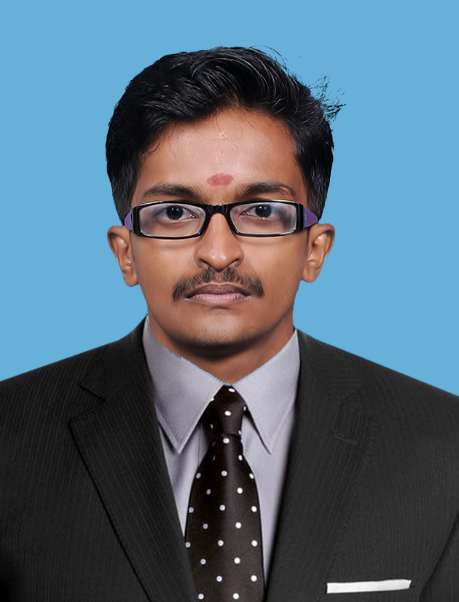

* WHY ME?

I am a Web designer & developer with B.E Computer Science & Engg graduation.

I have excellent design & coding skills, as well as an ability convert client requirements into exciting and responsive websites and android applications.

* SKILLS

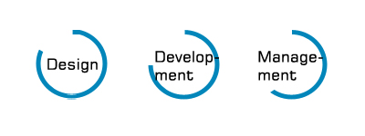

Project Management 

Creative 

HTML / CSS 

PHP 

Wordpress 

Android 

Eclipse 

Android Studio 

Dreamweaver 

Adobe Photoshop 

Adobe Illustrator 

Flash 

2015

**WORK EXPERIENCE**



**CREATIVE HEAD & MANAGING PARTNER** [July- Presnt]

MANYBRAINS  KANNUR

* Project Management & Team Leader;;;;
* Design & Develop Website & Mobile Applications
* Server Managing

**WEB & ANDROID DEVELOPER** [Oct – July]

CORPTECH TECHNOLOGIES  KANNUR

* Designed responsive website layouts.
* Developed backend for websites.
* Updating & maintaining the websites.
* Designed creative brochures and flyers.
* Design & developed Android Mobile application

**WEB DESIGNER** [Aug - Sept]

TRYCATCH TECHNOLOGIES  KANNUR

* Designed responsive website layouts.
* Updating & maintaining websites.
* Designed creative brochures and flyers.
* Designed company logos and visiting cards.

2011 - 2015

2009 - 2011

* EDUCATION

**B.E Computer Science & Engineering**

Visveraya Technological University, Belgaum  Mangalore

*Prasanna College of Engineering & Technology, Ujire*

Percentage: 63% (Avg 1-8 Sem)

**Plus two Computer Science**

Board of Kerala  Kannur

E K N S S G H S S Vengad

Percentage: 78%

2016

2015-2016

**OBJECTIVE**



## To achieve a challenging career in the field of Software / Web Development and Designing in a professional environment with my sincere inputs like hard work, enthusiasm and constant learning to furnish quality products as output, and as well play an active part in growth of the company.

­­

CERTIFICATIONS

* 3G Mob Communication - BSNL Mangalore
* Network Simulation II & HTML5 - PCET Mangalore
* Unity Game Development - Google Fest Mangalore
* TechBytes 2013 & 2014 - TCS: IT Services
* App Fair Contest - Google Fest Mangalore

 LANGUAGES

English 

Malayalam 

Hindi 

Kannada 

Tamil 

WORK PORTFOLIO



Capital Hypermarkets Thalassery- Website

Not Live



Baby Cinemas Koothuparamba- Website & Ticket Booking Application

Dwajen - Ras Al Khaimah Poultry & Feeding Co. – Website Development

Sultan Bin Zayed Heritage Festival - United Arab Emirates – Web & Mobile App

Not Live



Upbeat Digital - United Arab Emirates - Website Development

YGMS TRADING FZE - United Arab Emirates - Website Development

Mentor in your life - United Arab Emirates –Website Development

Pansun Group – Website Development

Dexline – Qatar - Website Development

Mobcity - 3 nodes innovations -Android App Development

Corpchat – Corptech Technologies -Android App Development

* PERSONAL INFORMATION

Activities: Driving, Listening Music, Watching TV, Chatting, browsing etc.

Strengths: Creative, innovative, problem solving ability and team leading

* DECLARATION

I declare that above statements are true to the best of my knowledge.