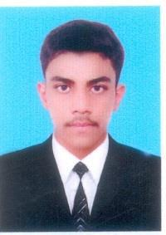

Touqir
Touqir.371238@2freemail.com

OBJECTIVES:

I want to join a challenging environment where I can do more and prove my abilities, to do some exceptional work in my professional career, to do work and learn and contribute in stimulating environment of any excellent organization according to my professional qualification and capabilities.

ACADEMIC QUALIFICATIONS:

QUALIFICATION | Years | Marks | Division | Board
Matric | 2011 | 664/1050 | 1st | BISE Faisalabad
ICS | 2013 | 890/1100 | 1st | BISE Faisalabad
B.sc | 2015 | 610/800 | 1st | GCUF

EXPERIENCE:

- 2 Years experience as Sales Man at Yes Mart

- 1.5 Years experience as a Pharmacy Sales Man.

COMPUTER SKILLS:

➢ Microsoft Office & Internet Surfing

CAPABILITIES:

- Hold tremendous Potential to complete the assigned duties with high sense of responsibilities.

REFERENCE:

➢ Will be furnished upon demand.

