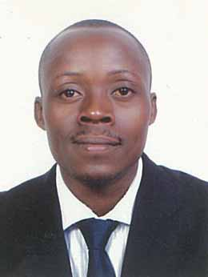
ROBERT.371243@2freemail.com
CURRICULAM VITAE
PERSONAL INFORMATION
Name: ROBERT
NATIONALITY: Ugandan
MARITAL STATUS: Married
LANGUAGE: English.
VISA: Employment Visa

CAREER OBJECTIVE
Am a hardworking male capable of providing excellent and exceptional customer service, clerical and administrative support in order to ensure the smooth running of business efficiently.
PROFESSIONAL EXPERIENCE
GOLF COURSE HOTEL KAMPALA-UGANDA
Position: Receptionist / Bell Boy
Duration: 5 Years
ROYAL SUITES HOTEL KAMPALA-UGANDA
Position: Receptionist / Night Auditor
Duration: 5 Years
PROFESSIONAL SECURITY COMPANY –UGANDA
Duration: 5 Years
Designation: Security Guard Part time.
GINCO GENERAL CONTRACTING COMPANY –DUBAI
Duration: Currently work here
Designation: Security Guard
- Developed and maintained a current and accurate filing system.
- Excellent check-ins and checkouts of guests in a timely manner.
- Excellent and exceptional customer service all times
- Balancing all P.O.S.cashiers through micros system
- Ensuring the proper balancing of all cash flows and floats
- Ensuring proper records between Housekeeping and front office.
- Running the End of day audit through the system
- Handling all guests complaints in a timely manner
- Coordinated the repair and maintenance of office equipment
- Ensuring a proper handling of guests luggage
- Ensuring the happiness and satisfaction of the guests all times
- Ensuring safety environment for the guests and staff
- Answered all incoming calls and handle caller’s inquiries whenever possible.
- Re-directed calls as appropriate and tookadequate messages when required.
- Greeted, assisted and/or directed visitors and the general public.
- Received, directed and relayed telephone messages and fax messages.
- Directed the general public to the appropriate staff member.
Picked up and delivered the mails where necessary
- Opened and dated stamp all general correspondence.
- Maintained the general filing system and filed all correspondence.
- Responded to public inquiries.
- Well knowledgeable with Opera and Fidelio Hotel software’s
- Observe for signs of crime or disorder and investigate disturbances
- Take accurate notes of unusual occurrences
- Report in detail any suspicious incidents

PERSONAL STRENGTH
- Ability to work under pressure and meet deadline.
- Team leadership, self-esteem and self-motivated.
- Able to work longer hours, dynamic and performance driven.
- Good communication skills and strong public relations
- Honest,Reliable,Dependable and Result oriented all times
- Quick learner,Smart and able to work Night Shifts

EDUCATION
- Uganda Certificate of Education (UCE)
- Uganda Advanced Certificate of Education (UACE)
- Security Certificate
- Diploma & Certificate in Hotel Managment

