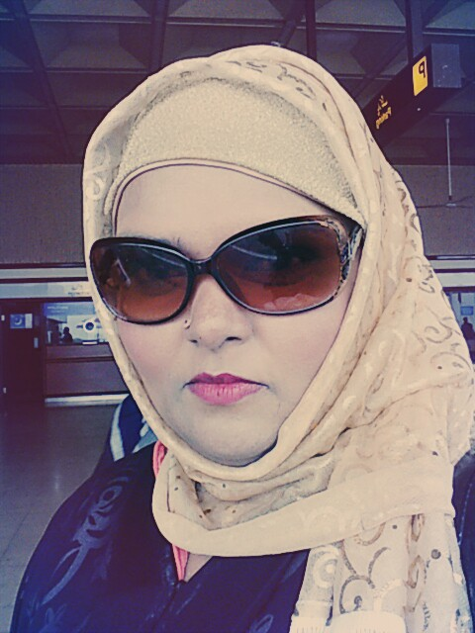
Afsheen.371260@2freemail.com

Afsheen

OBJECTIVE

To attain a challenging position in dynamic environment officering good opportunities for growth and learning that calls for full utilization of my talents and offers opportunities for application of knowledge to real life situations.
QUALIFICATION

- MBA from Federal Urdu University, Karachi.(in progress)
- M.A English literature from Federal Urdu University Karachi.
- B.ed from university of Karachi
- B.A from Karachi University
- B.S Environmental Sciences from Federal Urdu University, Karachi..
- Intermediate: P.E.C.H.S Govt. College.

NON ACADEMIC QUALIFICATION

- TESOL on DL
- English Language Course from Pak American.
- Executive communication Course from Pak American.
- M.S office course
EXPERIENCE

- In TSA as Lecturer of Functional English for CA & IELTS for ACCA, Examination Head of Soft Skill Development Dprt. 2016- Present
RESPONSIBILITIES

- Manage all student managerial issues.
- Student counselling for career and behavior.
- Behavior management sessions with students.
- Set examination for C.A functional English.
- Teachers training.
- Arranging workshops and training sessions for teachers and students.

- In UNITED NATION ASSOCIATION OF PAKISTAN as Correspondence officer , 2015-2016

- In DOMINO ENGLISH LEARNING as English language and IELTS teacher in Islamabad & Karachi. 2005-2015
RESPONSIBILITIES

- Manage all administrative issues.
- Recruitment selection of staff.
- Maintain all records.
- Teachers training.
- Maintain marketing and advertising .

- In C.D.G.K Call Centre training program as Administrator and Linguistic teacher / trainer.
RESPONSIBILITIES

- Interview Students and select them for different levels.
- Recruitment selection of staff.
- Maintain syllabus for all levels.
- Teachers training.
- Teaching executive / professional English class.

- In BRIGHT CAREER institute as Administrator.
RESPONSIBILITIES

- Recruitment selection of staff.
- Maintain syllabus for all levels.
- Teachers training.
- Teaching executive / professional English class.

- Pak American as E.L.T.

ACHIEVEMENTS

- Written English grammar book which is selected by in AMERICAN PUBLICATION.
- Translation of Mechanical books for G.C.D.
- Proof reading of English and Urdu book for Rehbar Publisher Karachi.
- Revised English Course book for G.C.D.
- Written Several Urdu dramas for PTV.
- Best all Pakistan debate competition winner.
- Best hasting competition winner in All Pakistan.
- Special Award holder for Science Exhibition.
- Work as an R.J on F.M 107.

PERSONAL INFORMATION

- Date of Birth : 27-09-1983
- Nationality : Pakistani
- Marital Status : Married
- Religion : Islam
REFERENCE

- Will be established on demand.

