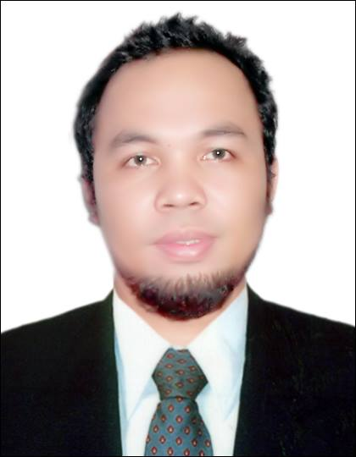

EDUARDO
EDUARDO.371262@2freemail.com

POSITION APPLIED: Civil Engineer

CAREER OBJECTIVE

To work in a creative, challenging environment that will home my analytical, technical, planning, management,
decision-making and communication skills in the field of Civil Engineering.

WORKING HISTORY
Civil Engineer Company : Al Wathba Engineering Consulting LLC Sept. 25, 2014 – June 21,2017
Projects: Villas and Buildings
Al Ain, Abu Dhabi, United Arab Emirates
Job Description :
- Structural Engineer : Responsible for Structural Designing of any projects.
- Site Inspector / QA QC / Field Engineer :Supervises and Responsible for checking the correct implementation of projects as based on approved plans in any of the projects.
- Monitor and Oversee implementation of the projects of the company
- Consultant Representative during concreting schedule in any project to monitor the quality of concrete being used and the quality or work in the project.
- Prepare the Bill of Quantity ( BOQ ) of any projects.
- Do Structural Plans and Details, Architectural Drawings and Drainage Plans.
- Inspect and do the approval of the structural works of the projects before submitting to town planning inspector for inspection and concrete approval.
Field Engineer Company : RN Vios Construction January 2014 – July 2014
Project: Three-Storey Residential Building,
Busay HiLand Compound, Busay ,Cebu City, Philippines
Job Description :
- Responsible for the efficient implementation of project design within specified schedule, plans and specification at minimum cost possible
- Supervises Foreman and Lead men of the assigned project
- Prepare activity schedule of the given project of the company
- Oversee implementation of the projects of the company
- Monitor program of works and ensure that all activities are kept within schedule
- Advance preparation of materials requirement to prevent delays
- Implement rules and regulation of the company including safety and housekeeping
- Secures necessary permits in the implementation of the Project
- Perform all job assigned by the General Manager
On-the-Job Trainee Company: Primary Structures Corporation April 2011 - May 2011
Project(s):
- Avalon Condominium (21-storey), Cebu Business Park, Cebu City
- Makoto 2-storey Warehouse Building, MEPZ 2, Lapu-Lapu City
Job Description :
- Engaged in assisting field engineers and project managers.
- Hands-on on formworks installation and erection.
- Hands –on on Rough Carpentry

Working Student Company: University of San Jose- Recoletos December 2007 - October 2012
Office Assigned: Our Lady of Mt. Carmel Parish-Recoletos
Job Description :
- Church Maintenance
- Church Property Custodian
- Choir and Altar server
- Draftsman and office clerk
- Accommodates clients inquiries
EDUCATIONAL BACKGROUND
Tertiary : Bachelor of Science in Civil Engineering
University of San Jose-Recoletos ;Cebu City,Cebu,Philippines
June 2007- October 2012
- University’s Working Student
Special Training : Primary Structures Educational Foundation Inc.
SKILLS Campus: General Maxilom Avenue, Cebu City , Philippines
April 6, 2011- May 27,2011
- Carpentry NC II ( Rough Carpentry)
- Scaffold Erection NC II
Secondary : Usmad National High School ; Usmad, Argao, Cebu, Philippines
June 2003 – March 2007
Primary : Mabasa Elementary School ; Mabasa, Argao, Cebu, Philippines
June 1996 – March 2003
SEMINARS ATTENDED
April 6-30, 2011 “Training on SCAFFOLD ERECTION NC II”
Primary Structures Educational Foundation Training and Assessment Center
SKILLS Campus, Gen. Maxilom Avenue, Cebu City
Certificate No: 6015 – 10 – CON – 145

May 2-27, 2011 “Training on CARPENTRY NC II”
Primary Structures Educational Foundation Training and Assessment Center
SKILLS Campus, Gen. Maxilom Avenue, Cebu City
Certificate No: 6015 – 11 – CON – 201

