CURRICULLUM 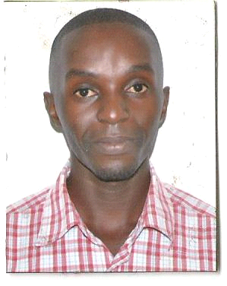 VITAE
SECURITY GUARD
DENNIS
DENNIS.371271@2freemail.com

PREAMBLE
An am ambitious self- motivated individual with a high quest to achieve throughout every level and task at hand. Never the less am able to evaluate and make realistic expectations of achievements possible in a given setting and resource considerations. It’s for this quest to achieve at all times I constantly seek to qualify myself through various working environments such that am able to output with excellence at any given opportunity of service.

PROFILE
Leader by nature, honest, enthusiastic, result oriented, self-motivated and innovative under graduate. I am a very dynamic person, open to challenges and ready to learn.

OBJECTIVE
To become one of the high profile employee within your company driven towards achieving the organizational/company goals, mission and objectives this country and the world at large, and can be proud of in this era of rapid technology evolution
OTHER SKILLS AND ABILLITIES:
- Great employee relations skill and management
- A high degree of punctuality
- Great team work reliability and flexible
- Excellent communication skills written and spoken
- Capable of working to a very high standard and on own initiative
- Flexibility and fitness to adjust and attend to emergrncy situations immediately.
WORK EXPERIENCE
SPENCON SECURITY GROUP, UGANDA
DOOR FRONT GUARD June 2015-July 2016
Duties and responsibilities
- Maintaining maximum security at all premises attached to me.
- Performed duties with attention to detail, speed, accuracy, follow-through ,courtesy, cooperation and working with minimal supervision
- thouroughly checked, signed and ensured that no illicit and illegal items are brought into the premises.
- observing, checking and maintaining law and order in the gazeted places.
- be a vigilantee on all sceens or susppicions of crime related factors.
- Reporting and observing about any crimes and ensuring that immediate effect is done and actions with respect to the state rules and regulations.
- Assisting other departments when need arises.
- Attending morning briefings to what tasks we have for the day, knowing V.I.P’s and other special dignatories presence and security.
ARROW SECURITY GROUP UGANDA
WATCHMAN
September 2012- January 2015
Duties and responsibilities
- know and enforce rules and regulations to prevent criminal activity before it happens.
- monitor points of access in a building or property to allow entry only to individuals with the correct identification or authorization
- investigate and report signs of damage or unlawful entry as it occurs
- contact authorities and make written or verbal reports to law enforcement.
- In emergency situations, they may provide first aid or assistance and alert first responders.
ACADEMIC QUALIFICATIONS

B.AED Bachelor of Arts in Social Sciences –Makerere University ,3.68 (2011-2015)
College Courses Economics, General paper, Entrepreuership, History (UACE- 2010)
Mathematics , English, Biology, chemistry,Islamics (UCE - 2008)
ADDITIONAL SKILLS
Computer Application skills with comprehension of Ms Word, Excel, Power point,illustrator
SPECIAL SKILLS
-Explosives Detection Dog Instructor.
-Explosive Detection Dog handler.
-Security guarding, armed and un armed.
-Computer skills.
-Driving skills
-Leadership skills.
TRAINING ATTENDED:
COURSE DURATION ATTAINED AT.
Basic security Six weeks Saracen uganda limited
Course
Basic security Six months Brz uganda limited
Basic computer three months KYDL cmputer training Centre
applications
LUNGUAGES
LANGUAGES SPOKEN RATING
English Excellent
ARABIC Basic
Referees
Available Upon the request

