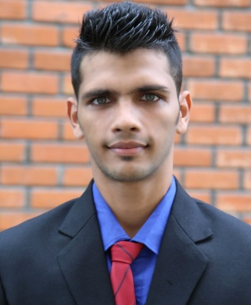
NAIZILE
NAIZILE.371279@2freemail.com

SUMMARY / OBJECTIVE
Course | Institution | % Marks | University / Board | Year of Passing
MBA | St Aloysius College of Management and Information Technology (AIMIT) | 70.15 | Mangalore University | 2017
B.Com | St Aloysius College Mangalore | 65.05 | Mangalore University | 2012
12th / Pre-  University | Padua PU College Mangalore | 66.18 | Karnataka Board | 2009
S.S.L.C | Shri Mahalingeshwara English Medium School | 59.36 | Karnataka Board | 2007
To work in an organization where I can utilize my skills and abilities while enhancing my knowledge to achieve professional satisfaction and personal development, I would want to inculcate in me the ethics that are required to survive, work and improve myself to cope up with today’s competitive corporate world.

ACADEMIC DETAILS

INTERNSHIP
Company: Microsoft
Project Title: A study on the parameters that are to be considered for hiring start-ups.
Expertise Acquired:
- To integrate with the Start-ups.
- Co-ordinating Think Next Event – 2016
- How to conduct a incubator meet at Think Next - 2016
- More confidence in career direction
- Completion of Project (Summer Internship Project)

WORK EXPERIENCE

Company: Maharashtra State Electricity Transmission Co. Ltd
Duration: 2 years 4 months (June 1st 2012 - September 31st 2014)
Job Title: Account Assistant
Roles and Responsibilities:
- Posting daily financial transactions in SAP - accounting software and recording cashbook
- Preparing contactors tax invoice. Submission of contractors TDS, WCT service tax and professional tax chalan monthly. Submission of quarterly report of TDS to government through Chartered Accountant.
- Calculating monthly salaries to the employees and issuing temporary impress.
- Identified process on sorting out the queries of statutory, ISO, cost and internal audit.
- Preparing Bank reconciliation statements and preparing trial balance.

TECHNICAL SKILLS
Computer knowledge | Windows 98/XP/7/8/8.1/10  C Programming, MS Office applications Excel Word PowerPoint Outlook, Photoshop, and SPSS  SAP-System application product (Finance module)
INTERESTS

- Painting, Sketching
- Reading and Surfing.
- Playing Cricket.
- Photoshop
- Dancing
PERSONAL DETAILS

Date of Birth : 29/01/1992
Nationality : Indian
Languages known : English, Hindi, Konkani, Marathi, Kannada, Tulu
Gender : Male
Driving License : Yes

I confirm that the information furnished above is true and correct to the best of my knowledge.

