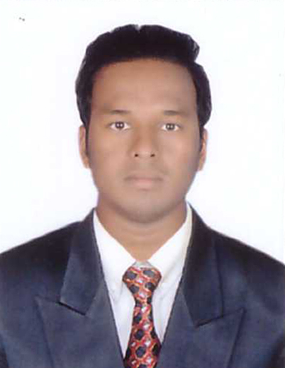
RESUME

MAHESH
MAHESH.371293@2freemail.com

Objective:

Seeking an opportunity in reputed firm, where I can learn and enhance my potential in succeeding professionally and utilizing my skills and expertise to lead bright career with integrity in financial and character wise dedication to contribute as a key team player.

Educational Qualification:

- Bachelor of Degree in computer science and engineering from JNTU Hyderabad with 1st class from 2008-2012

- Inter MPC from State board with 1st class in the year 2006-2008

- SSC from state board with 1st class in the year 2006

Experience:

- Desktop support (Sound engineer)for a period of Two years (2 years) from 01/04/2012 to 01/04/2014 for the company (Teluguone) Hyderabad.

- Sales man for a period of One year from 02/05/2014 to 02/05/2015 for the company (Airtel) Hyderabad.

- Cashier cum admin for a period of 1year from 02/06/2015 to 02/06/2016 for the company (Omega Hospitals) Hyderabad.

- Sales executive for a period of 2 months in Du (out door) Dubai

- Sales promoter for a period of 1 month in Linksys Dubai

Course certificate:

- Ms office, Ms excel, PowerPoint, Ms Word, Hardware and networking

Hobbies:
- Internet browsing
- To learn about new technologies
- Chatting with friends
- Listening Music

Strengths:
- Hard working
- Honest
- communication skills
- Leadership qualities
- Optimistic

Declaration:

I hereby declare that the above written particulars are to the best of my knowledge and belief.

