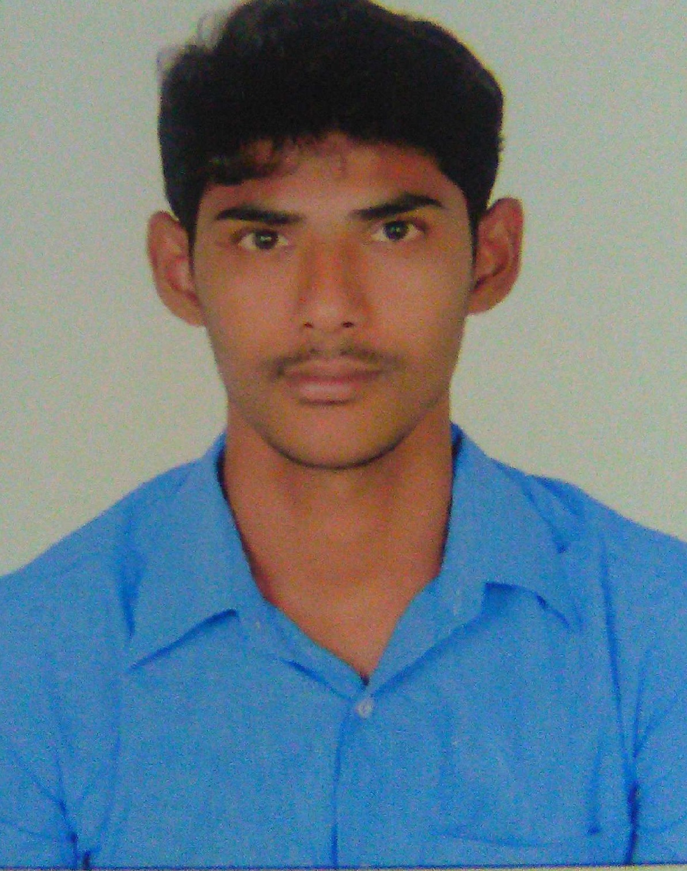
PATAN
PATAN.371329@2freemail.com

CAREER OBJECTIVE
Seeking the position of IT Engineer & Windows Admin/Networking to enhance my knowledge and skills in a progressive and renowned organization

CAREER HISTORY:.
Mind square Technologies Bangalore India: November 2016 to June 2017
IT Engineer:
Client 1: QUEST GLOBAL Bangalore India:
- Install, configure and support Microsoft technology solutions on windows 2003/2008 platform hosting web and database applications, while maintaining security patches, antivirus updates, backups, monitoring and performing routine server maintenance environment that includes a domain controller, Active Directory 2008, DHCP, DNS, and a Microsoft Exchange server.

- Performed system maintenance duties such as system backups and file restoration from both disk and tape backups
- Deployed anti-virus(Symantec), Encryption(Mcafee) and Druva Backup software to client systems using remote consoles and directly at the workstations
- Perform daily system monitoring, verifying the integrity and availability of all hardware, server resources, systems and key processes, reviewing system and application logs, and verifying completion of scheduled jobs such as backups
- Hardware and software system related to CCTV devices ,Telephones,Attendence Access control devices .
- Configuring and managing Network printers and plotters through print server.

- Updating the patches like security, Critical, WSUS patches & updating application patches on monthly basis (When patches are released by Microsoft).

Client 2 :MATRIX CELLULAR INTERNATIONAL SERVICES PVT LTD Bangalore India
- Providing daily operational support and system administration for core network infrastructure
- Checking and troubleshooting LAN and WAN Networks
- Maintain company IT stock
- Configuring and troubleshoot New Laptop or Desktops with Security and softwares
- IP CCTV maintaining and backup
- Maintain IP Telephone and resolving issue of phones
- Ensure technology documents and certificates such as productregistrations, SSL certificates, maintenance agreements, service contracts etc.

SRI TECH INC Bangalore India– August 2015 to OCT 2016:
IT Engineer:
Job Profile – Responsible for the installation, support and management of network technologies operating in 24x7 business environments
Duties:
- Identifying, diagnosing, and resolving network problems.
- Performing complex implementation and maintenance tasks on the LAN and WAN.
- Providing daily operational support and system administration for core network infrastructure.
- Configuring LAN equipment.
- Supporting windows desktop technologies.
- Working on large scale, publicly facing websites.
- Monitoring network performance.
- Configuring Routers
- Participating in 24x7 on-call rotations.
- Ensuring that service level agreements are met.
- Installation and troubleshooting of Printers, Scanners, Desktop and Laptop when end user required
- Troubleshooting network connectivity in a LAN/WAN environment
- OS Troubleshooting and Handle Remote tool.
- Installation of new hardware and software.
- Configuring Routers
- Supporting windows desktop technologies
- System monitoring performance.
- Update Anti-virus software in client machine.
- Firmware update on Hardware and software.

KEY SKILLS AND COMPETENCIES:
- Network Engineering
- Willing to travel based on assigned project demands. .
- Strong knowledge of Microsoft Office.
- Accurate documentation skills.
- Comprehensive knowledge of networking concepts.
- Evaluating new software and hardware technologies.
PERSONAL:
- Dealing effectively with highly stressful situations.
- Maintaining knowledge of emerging networking technologies.
- Able to drive results with a sense of urgency relative to the end user.
- Willingness to work out of hours.
- Can perform all duties with minimal supervision.

IT Technical COURSES Done:
- CCNA
- MCSE
- A+
- N+
- RHEL6
EDUCATIONAL QUALIFICATIONS:
- B.TECH in Electronics and communication engineering
JNTUK University - Guntur, Andhra Pradesh

- INTERMEDIATE (1 AND 2 PUC) IN M.P.C in Charles Junior college in –Chilakaluripet-Guntur, Andhra Pradesh.

- SSC in Luthuren High School Edlapadu-Guntur Andhra Pradesh.

PERSONAL DETAILS:

Name : PATAN
Nationality : Indian
Date of Birth : 10 June 1994
Gender : Male
Languages Known : English, Hindi, Telugu and Urdu
Visit Visa Status : 25- Sep - 2017

