CURRICULUM VITAE
SHAMNAD SHAMNAD.371343@2freemail.com 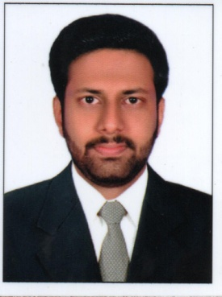

Personal Details
Name :Shamnad
Nationality :Indian
Gender :Male
Date Of Birth :06-March-1995
Language known:English, Hindi,Malayalam

- h

Objective
To work for a growing company that will provide me a possibility of growing within it and allow the development of my abilities and skills in favour of company’s mission and my environment.
Education
Higher Secondary School (plus two):RKD Higher Secondary School, Trivandrum. Currently am doing my Bachelors degree through distant education.
Job Experience
Fresher
Key Skills
- Fluent in English and Hindi.
- Pc skills, MS Office, Excel, PowerPoint and others.
- Organisational and interpersonal skills.
- Attractive personality and strong communication skill.
Extra Curricular Activities
Participated in debates of various television programmes.

