Career Objective | Every assignment taken up by me, I consider it as a unique opportunity to create and add value through a hands-on learning approach. I wish each one of such, to contribute to the growth and objectives of my organization by way of achieving my own career growth.
Exposure  Experience | High Rise buildings  - Structure work  - Finishing / Fit Out work  - Bar bending Schedule for beam &slab  - Precast fabrication of staircases  - Epoxy flooring  - Waterproofing of swimming pools, underground tanks, electrical rooms  5 years of total experience
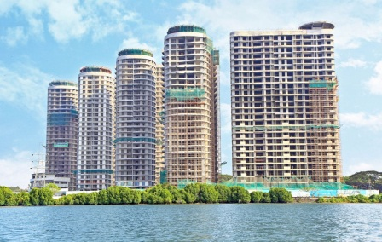  Five high – end residential towers as part of the Tritvam premium waterfront residential complex in the port city of Kochi on India’s west coast. The 25 storey towers comprise about 475 (Three and Four Bedroom) apartments. The complex occupies a 3.4 hectare site includes a club house, landscaped podium & car park facilities.  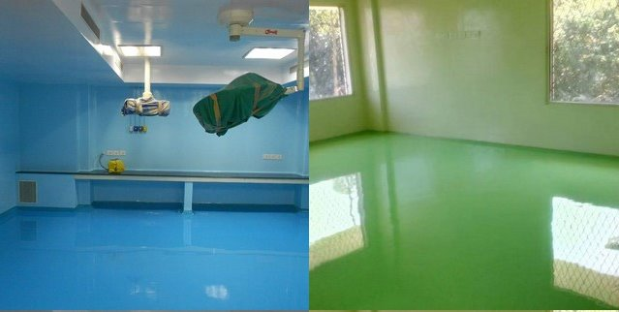  Academic Qualifications  Technical exposure  Achievements & strengths  Personal details  Declaration | Previous Company Name: Leighton India Contractors Pvt. Ltd  Project Name :Alliance Tritvam  Client: TATA Realty & Infrastructure LTD  Project Type : Residential  Project cost : US $57 Million  Designation :Site Engineer (4years’ experience)  Roles & Responsibility(Structure work execution / Finishing Works execution )  - To monitor & inspect the construction work and assure that it is done in full accordance with the drawings, technical specifications and bills of quantities  - Managing 7000 m2 of concrete structure Tower 3 & 4(G+25 +helipad)  - Execution of precast staircase fabrication and fixing  - To execute all fit out / interior site works of 4 towers as per the plan/schedule  - Prepare manpower utilization/work schedule (Gantt Chart)  - Monitor inventory, anticipated requirements/purchases and minimize the wastage of construction/finishing materials  - Prepare correspondence &reports (punch list, manpower report, activity report etc.)  - Prepare Conduct Quantity Surveying, purchase requests  - Prepare, develop and enforce procedure like safe Work Method Statements, Inspection test plan, RAR, JSEA and ensure work methods are in  compliance with company’s systems and procedures.  Current Company Name: Prism Engineering Services  Projects: Internal finishes of Credence Hospital, Trivandrum  Water proofing of water tanks at TATA Tritvam, Ernakulam  Water proofing & Epoxy floor and walls at Taluq Hospital, Ernakulam  Internal finishes at PDDP ICE CREAM PLANT, Ernakulam  Designation :Project Engineer (1 year experience)  Roles & Responsibility  To monitor site execution of Finishes works comprising of plastering, tile /marble/granite fixing, water proofing and epoxy flooring , as well as cost estimation for the above works.  Educational Profile  Institution Degree/Certificate Semester SPI( %)  BIT, Durg B.E. in Civil Engineering  Semester 1 6.2  Semester 2 6.2  Semester 3 6.0  Semester 4 6.0  Semester 5 6.0  Semester 6 6.0  Semester 7 7.0  Semester 8 7.5  Vocational Training on ISO 14001 Certification for water purification tank of Bhilai Steel Plant.  - Major Training on Construction of boundary wall of BALCO Plant extension.  - Minor Project on Design Of A Plate Girder.  - Major Project on Detailed Analysis Of Plate Girders and Plate Girder Bridges.  - Hard working  - Ability to get maximum productivity by increasing the OUTPUT and minimizing the INPUT  - Ability to work in conjunction with the construction team adhering to the SAFETY requirements as per the company's policies.  Name : Arjun  Date of Birth : 05/05/1989  Sex : Male  Nationality : Indian  Marital Status : Single  Languages Known : English, Hindi, Malayalam, and Tamil  - I consider myself familiar with Civil Engineering aspects and I am also confident of my ability to work in a team.  - I hereby declare that the information furnished above is true to the best of my knowledge.

