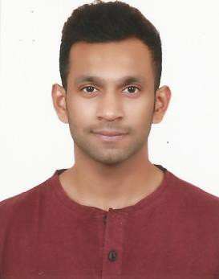
Marwan
Marwan.371354@2freemail.com

Personal Summary  Education | A highly motivated and enthusiastic individual who enjoys being part of a successful and productive team, with the desire for a progressive career. My sensing personality and ability to listen helps recognize the needs of the organization. I consider myself capable of using my own initiative, experience and resources to develop top class results.  Heriot-Watt University Dubai, United Arab Emirates Bachelor of Engineering in Mechanical Engineering (Honors), September 2012-May 2016  Emirates Aviation College Dubai, United Arab Emirates National Certificate in Aerospace Engineering, September 2010-July 2011  Higher Secondary Education Dubai, United Arab Emirates 10th and 12th Grade
Work Experience | Atlas Copco, Dubai U.A.E  Marketing Engineer Intern August 2016 – October 2016  Job Description  - Undertake market survey of companies in the Engineering sector  - Provide technical assistance or alternatives to customers  - Record and maintain log of daily and weekly visits  - Procure valuable information about potential customers

AMY Gold & Diamond, Dubai U.A.E

Sales Intern November 2016 – May 2017
Job Description

- Monitor sales of products
- Interact with potential clients and prepare quotations
- Technical assistance to the Sales team
- Produce and manage daily reports

DU Telecom, Dubai U.A.E

Data Controller February 2011 – February 2012
Job Description
- Handle personal details of subscribers
- Update client database manually

Fujitsu Siemens, Dubai U.A.E

Promoter September 2012 - October 2012

Job Description
- Promote brand awareness and sales of Fujitsu Siemens laptops
- Meet sales target and track inventory status
- Answer customer queries about the product and services
- Demonstrate product features and novelties
Skills | Software: Microsoft Office, Autodesk Inventor, ABAQUS, PTC Creo  Machines: Mill, Lathe, Drill press, Saw, Filing, Soldering  Languages: Fluent in English, Malayalam, Hindi
Personal  Details | Nationality: Indian Marital Status: Single Date of birth: 27/06/1992 Visa: Visit Visa  License: Dubai driver’s license

References provided upon request.

