Fernan
Fernan.371360@2freemail.com
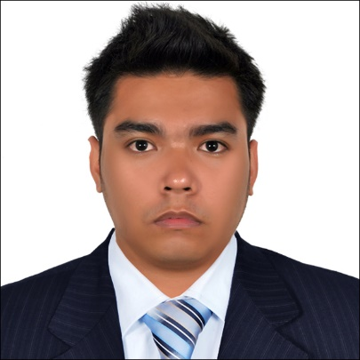

CAREER OBJECTIVES
Seeking career employment in a centralized corporation commensurate with my skills, experience and education. In order to enhance my professionalism and capabilities within the service industry.

IT SUPPORT ENGINEER / IT SPECIALIST / IT TECHNICIAN / NETWORK ENGINEER

EDUCATION  Bachelor of Science in Computer Engineering  (2008 – 2013)  Asian College of Technology  Cebu City, Philippines  Computer System Technician  (2005 – 2008)  Southern Leyte State University  Sogod Southern Leyte, Philippines  CERTIFICATIONS & TRAININGS ATTENDED  - TESDA – NCII in Computer Hardware Servicing  - CCNA – LAN Switching and Wireless  - CCNA – Accessing the WAN  - Premises Cabling Technician –  Structured Cabling Copper and Fiber Optics  SKILLS  - Excellent technical knowledge of PC’s and desktop hardware.  - Excellent listening and questioning skills, combined with the ability to interact confidently with the clients to establish what the problem is and explain the solution.  - Problem solving skills.  - Software and Hardware Troubleshooting.  - Windows XP, Windows 7, Windows 2000/2003/2008 experience.  - Ability to operate tools, components and peripheral accessories.  - Microsoft Office 2007, Office 2010 support.  PERSONAL DATAILS  Nationality: Filipino  Sex: Male  Height: 5’5  Date of Birth: September 16, 1989  Age: 27 Years Old  Civil Status: Single  Language: English,Tagalog  Visa Status: Residence Visa  REFERENCE: Available upon request | WORK EXPERIENCES  IT Support Engineer/ IT Specialist  International Patience Care(IPC)  Abu Dhabi, UAE  January 2015 – Present  Responsibilities:  - Install, upgrade, support and troubleshoot XP, Windows 7, Microsoft Office 2007, printers and restoring to service any terminal service client, personal computers (PC) or notebooks  - Experience in structured cabling.  - PC assembly and troubleshooting, PC OS and software installation, hardware installation, problem isolation.  - Equipped w/ good knowledge in Cisco Network System (routers, switches, basic network configuration)  - Talking staff or clients through a series of actions, either face-to-face or over the telephone, to help set up systems or resolve issues.  - Knowledge in Linkys Router.  - Strong analytical and trouble shooting skills WAN, LAN, WLAN.  - Type documents, reports and correspondence  - Retrieve information when requested  - Maintain MS Active Directory, DNS, DHCP and TCP/IP  - Knowledge on Backup systems & NAS devices  IT Specialist/Desktop Support  LGU Local Government Unit, Southern Leyte, Philippines  July 2013 – August 2014  Responsibilities:  - Administer and support PC & Network Hardware and Software.  - Install, configure and upgrade PC hardware and Software components.  - Assist department with projects as needed.  - Conducting electrical safety checks on computer equipment.  - Installation and maintenance of Windows Server 2003 & 2008  - Active Directory and Group Policy  - Knowledge in CCTV Installation  - Troubleshoot all PC/Network problems.  Computer Technician  Geafah Internet Café, Cebu City Philippines  October 2010 – February 2012  Responsibilities:  - Prepare computers for installation  - Monitored and responded to hardware and software problems.  - Maintain logs for all computer activities  - Carry out regular computer maintenance duties  - Perform preventive maintenance duties  - Provided network troubleshooting and support  Computer Technician/ Desktop Support  Realtek Service Company, Cebu City Philippines  April 2008 - August 2010  Responsibilities:  - Monitored and responded to hardware and software problems.  - Installed and configured network hardware and software.  - Provided network troubleshooting and support.  - Provide technical support to businesses and individuals.  - Lay complex networks using wires, modems, routers and wireless devices.  - Trained end-users

