MADHINA
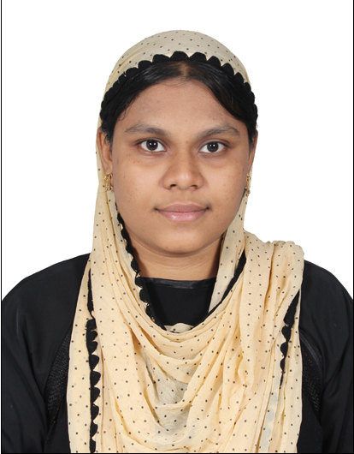
MADHINA.371395@2freemail.com

CAREER OBJECTIVE

Intend to prove my talents in my career with leading Corporate, which will help me to explore myself and realize my potential. Willing to work as a key player in challenging & creative environment.

EDUCATION RECORD

EXAMINATION | INSTITUTE | YEAR
B.E in Computer Science Engg. | K.Ramakrishnan College of Engineering (affiliated to Anna University), Trichy – 620001 | 2012-2016
XII (State Board) | K.A.P. Vishwanatham Higher Sec School, Trichy – 620018 | 2011
X (State Board) | K.A.P. Vishwanatham Higher Sec School, Trichy – 620018 | 2009

TECHNICAL SKILLS

Operating System: | Windows family
Office Tools: | MS Office, Visual studio
Languages: | C, C++, Java basic, Information System

HIGHLIGHTS

UG Project | Title : “A Secure Cost Effective Multi Cloud Data Hosting Using  Adaptive algorithm” IN CLOUD COMPUTING.  Duration : 3 months.  Concise : which proposes to store data with maximum availability  and with high security. It also allow to transfer data  within cloud devices. It allows to transfer data by  copying the URL link
Extra-curricular Activities & Hobbies | - Organized various college functions like symposium and cultural events.  - Interested in Photography.  - Fascinating in Paper craft and Works of Art  - Listening to music, Surfing Internet, Interested in Dance.  - Socializing
Co curricular activities | - Presented a project on “E-Doctor” in TECH-EXPO event conducted in our college.  This paper proposes to consult a doctor through online . This  will helpful in case of unavailability of doctors .  - Undergone a Workshop at HCL Technologies, Chennai on “Ethical Hacking”.  An ethical hacker is a computer and networking expert who  systematically attempts to penetrate a computer system or  network on behalf of its owners for the purpose offinding  security vulnerabilities that a malicious hacker could potentially  exploit.
Achievement | - Participated in GUINNESS WORLD RECORD EVENT (SYMBOL OF HUMAN CURRENCY FORMATION) On 26th Jan 2015 in Periyar University, Salem.

INTERPERSONAL SKILL

- Responsible attitude aimed at ensuring positive outcomes of assigned projects.
- Ability to reinforce concepts in a positive manner.

PERSONAL INFORMATION
Language Known : Tamil,English, Urudu
Date of Birth : 01-03-1994
Marital Status : Married
Nationality : Indian

Declaration :

I hereby declare that all the details furnished above are true to the best of my knowledge and belief.

