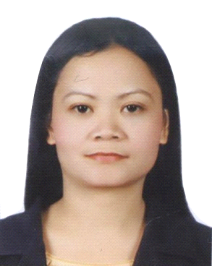
NANCY
NANCY.371400@2freemail.com
OBJECTIVE:
To work and to become an asset to whichever institution I will be dealing with as well as to share my knowledge and skills I gained from my experiences. Contributing the best of my abilities towards the betterment and success as well as the improvement of my professional and interpersonal skills.
QUALIFICATION:
MINISTRY OF HEALTH (MOH) LICENSE:– Dental Assistant Technician (A)
WORK EXPERIENCE:
DENTAL ASSISTANT – FULL TIME
SARA DENTAL CLINIC
AL WAHDA STREET SHARJAH, U.A.E.
SEPTEMBER 15, 2008 UP TO PRESENT

- Acknowledge and assist patients coming in to the clinic.
- Help in taking out the file and putting back files.
- Check and take initial vital signs of patients prior to treatment.
- Sterilize instrument to be use prior to treatment .
- Prepare the treatment room and disinfect all the equipment inside the treatment room.
- Proper drape the patient and prepare, arrange instrument needed for the treatment.
- Presence of mine all the time while on the workplace, especially inside the treatment area.
- Maintain cleanliness and orderliness inside the treatment area all the time.
- Proper segregation of waste.

MEDICAL ATTENDANT – FULL TIME
IDICA’S MEDICAL CLINIC
MALASIQUI, PHILIPPINES
FEBRUARY 2002 – JANUARY 2006

- Acknowledge patients visiting the clinic and assist them their needs
- Answering phone calls and scheduling patients who want to have an appointment with the doctor
- Check patients files visiting the clinic
- Taking initial vital signs prior to consultation or treatment

DENTAL ASSITANT – FULL TIME
PAGSOLINGAN – SOLOMON DENTAL CLINIC
BAYAMBANG, PANGASINAN PHILIPPINES
JULY 1998 – SEPTEMBER 2001

- Responsible in sterilizing all the instrument to be use prior to each treatment
- Assist and give friendly services to the patients
- Prepare the patients, and arrange the instrument needed for the treatment with the guidance of the doctor
- Maintain cleanliness and orderliness of the treatment area at all times
- Give some general instructions or friendly tips regarding how to take care of their teeth

PHYSICAL THERAPIST STAFF – FULL TIME
ST. ISIDORE PARISH PHYSICAL THERAPY CLINIC
LABRADOR PANGASINAN, PHILIPPINES
OCTOBER 1997 – APRIL 1998

- Check and take initial vital signs of patients prior to each treatment
- Monitor each patients reaction while undergoing treatment
- Participate in individual patients care and team conferences
- Review the patients chart and obtain current information prior each treatment
- Modifies and giving input into the patients plan and care.

EDUCATIONAL ATTAINMENT:

BACHELOR OF SCIENCE IN PHYSICAL THERAPHY
VIRGEN MILAGROS UNIVERISTY FOUNDATION
TALOY DISTRICT SAN CARLOS CITY PANGASINAN

PERSONAL INFORMATION:

Civil Status: Single
Nationality: Filipino
Visa Status: Employment Visa

I CERTIFY TO THE CORRECTNESS OF THE ABOVE INFORMATION

