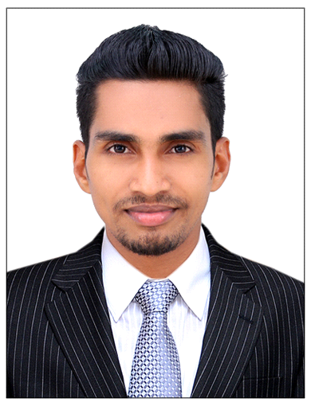
HARSHAD
HARSHAD.371428@2freemail.com

Position Applied : Interior Designer& Architectural Draughtsman

Carrier Objective:

Willing to work for a reputed organization where my potential and analytical skills will fully utilize and work as an effective team member. Seeks a suitable position that allows me to implement my skills and knowledge and of same time that gives me an opportunity to learn and adopt new things.

Over View Experience:

- Worked as Autocad Draftsman and 3dsmax designer for 2 years in JAS construction kannur,kerala,India
- Worked as Autocad Draftsman and 3dsmax designer for 2 years in Alzawaya Alarbaa Engineering consultants LLC. Abudhabi

Key Experience:

- Preparing Auto Cad plans, Elevations and Detailing.
- Preparing Designs Using 3ds Max and Autocad.
- Layout, Printing, Plotting.
- Preparing 3DDesigning,V Ray lighting and V Ray Rendering.
- Interior Design and Detailing using 3ds Max.
- Preparing presentations in AutoCAD and Photoshop.
- Assisting Architects in Planning and Designing.

Educational Profile:
- Draughtsman (civil) G-TECH India in June 2012
- Plus Two (Govt of Kerala).
- SSLC(Govt of Kerala).

Computer Skills:

- AutoCAD 2D
- 3Ds Max with V-ray
- Adobe Photoshop
- MS Office
- Operating Systems – XP, Windows 7 and 8
- Email, Internet Browsing

Personal Skills:

- Good Communicative skills.
- Leadership and Team work.
- Planning and Organizing.
- Ability to handle all types of Drawings.
- Self – Motivated.
- Self-Confident , Honest & Hard Working.
- Having an immense quest to continuously upgrade my skills.
- Ambitious, hardworking and committed to excellence.

Personal Details:
Gender : Male
Nationality : Indian
Marital Status : Single
Place of Issue : Kozikode, Kerala ,India.
Languages Known : English & Malayalam& Hindi
Relegion : Islam

Declaration:

I hereby declare that the above information furnished by me is true to the best of my knowledge and belief.

