CURRICULUM VITAE
RAKESH.371433@2freemail.com 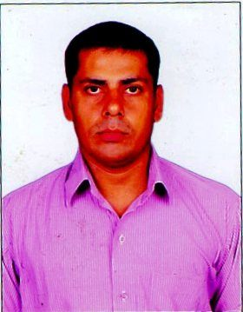
RAKESH

CAREER OBJECTIVE

Seasoned, dynamic and astute professional with 15 years of extensive experience in Indian Navy in the field of operating/management of Radio and Satellite Communications. My objective is to carve a niche for myself in an organisation by working as a Radio Communication Supervisor/Training Chief/ Security Administrator/ NBCD (Fire Fighting) specialist while contributing effectively for the growth and achievement of the organisational goals.

PROFESSIONAL QUALIFICATION

- Petty Officer Radio (Tel) Qualified
- Diploma in Telecom (Wireless and EW), Cochin University of Science and Technology, Kochi (India)
- Certificate of Information Assistant Course in Computer and Multi Media from APTECH/SSI Education
- Certificate of Advance Diploma in Fire & Industrial Safety form Royal Institute of Fire & Safety, Visakhapatnam (India)
- Certificate of Diploma in Office Automation from Creative Computers, Visakhapatnam (India)

CORE STRENGTH

- Man and Material Administration
- Complete dedication & Positive thinking, Ability to work for a long
duration and willingness to learn & improve
- Communication Skill
- Knowledge of Modern IT
- Command over Fire Fighting
- Vigilance (Security Management), Maintaining order and discipline.

ACADEMIC QUALIFICATION

- 10th (Science & Maths)
- 10+2 (Science/PCM)
- Graduation awarded by Indian Navy in Feb 2015

WORK EXPERIENCE (INDIA)

Served Indian Navy for 15 years in Radio Communication Wireless & Electronics Warfare Branch and retired on 28 Feb 2015 in the rank of Petty Officer Radio (Tel). During my Naval Service, I have carried out the following duties:

- Independent charge as Head of the Department (Communication & IT)
- Supervising a modern telecommunication office ashore and afloat
- SATCOM & GMDSS Equipments
- Wireless/Visual Communications
- VHF/UHF/HF Tx/Rx Communication Equipments.
- Fire fighting and Damage control
- Security and Vigilance duties
- Computer Word-Processing, data entry, installation of software,
Multimedia, Formatting, Assembling/Maintenance of PC

WORK EXPERIENCE (UAE)

Presently doing job at Abu Dhabi, UAE in Marine Based Company since 20th May 2015. Main role of this present job briefed in below points:

- All Office Work related to Vessels Sailing, Hiring etc.
- Preparation for Chattering of Vessels related office job.
- Controlling the movements of Vessels.
- All Marine works related to Communication / Radio Section.

PERSONAL PROFILE
Date of Birth : 06 Jan 1981
Marital Status : Married
Religion : Hindu
Nationality : Indian
Languages known : English & Hindi
Hobbies : Sports & Music
Salary Expected : Negotiable

DECLARATION:

I hereby declare that all information given above is correct to the best of my knowledge and belief.

