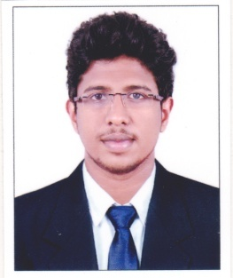
RESUME
LINU
LINU.371435@2freemail.com

Career objective

To have a growth oriented and challenging career, where I can contribute my knowledge and skills to the organization and enhance my experience through continuous learning and teamwork. To work with an organization, which can provide me constant learning to intellectual growth, enhance me creative skills and to achieve top cadre and making positive contributions towards the organization.

Academic Qualification
Course | University/Board | Institute | Year of passing | CGPA
B.E- Mechanical Engineering | Anna University | M.E.T Engineering College, Chenbagaramanputhoor | 2016 | 6.39
Higher Secondary | Matric | Nair Samajam Higher Secondary School, Mannar | 2012 | 68.5
SSLC | Matric | Mahatma Boys High School Chennithala | 2010 | 65.00
Other Educational Qualifications
- Diploma in oil & gas
- QA & QC inspection
- Non Destructive Testing ( NDT level 2)
Software proficiency
- Software known: Auto Cad, Ansys,Catiya ,Pro.E
- Office suite: MS-office, Ms-excel, Ms-powerpoint
Area of Interest
- Automobile Engineering
- Manufacturing Technology
Main Project  Project Area : Automobile Engineering
- Project Title : “Hydroxy Powered Two Wheeler”
- Project Role : Team Member
- Software used for Designing : Hap, AutoCAD
- Software used for Analyzing : Ansys

Experience : QC ENGINEER
Currently working as QC ENGINEER in Ocean Dreams Marine Services from January 15-2017 to till date

Achievements and Extra-curricular activities
- Participated and won prizes in English essay competition at school level.
- Active participant of NSS and Active blood donor.
- Participated and won Prizes in Quiz Competition at College level

Personal Trait
• Creative and logical
• Problem solving ability
• Co-operative and keen observer

Hobbies
- Playing Volleyball, Basket Ball,
- Singing and Hearing Songs
- Driving

Declaration

I hereby declare that all the details furnished here are true to the best of my knowledge.

