CURRICULUM VITAE
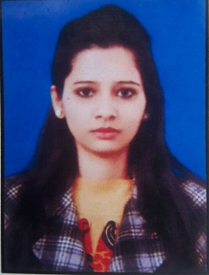
Swati

Swati.371449@2freemail.com

CAREER OBJECTIVE

I present myself with a strong desire to achieve the organizational goal with abounding self-confidence keeping in mind every kind of objection, resistance and obstacle as a challenge. With excellent analytical, problem solving, communications and interpersonal skills I look forward towards a progressive and challenging career.

TECHNICAL SKILL

- Basic Computer Knowledge.

EDUCATIONAL QUALIFICATION

Bachelor of Education (B.Ed.) Passed in 2015 from IGNOU with 73%

Master of Arts (Sociology) Passed in 2012 from M. J. P. UNIVERSITY Bareilly U.P. With 60.44%

One Year Post Graduate Diploma Course in Biotechnology (Tissue Culture) Passed in 2011 from D.N. Polytechnic Meerut U.P. with. 81.7%

Bachelor of Science (Botany Chemistry) Passed in 2009 from M. J. P. UNIVERSITY Bareilly U.P.

Year wise break up of Graduate (B.Sc.) marks:
Semester | I | II | III | (B.Sc. Aggregate)
Percentage | 70.00% | 63.2% | 64.4% | 65.86%

Pre Degree Academic Record:
Class Degree | Year | Board/ University | % | Division
High School | 2004 | U.P. Board | 52 | Second Div.
Higher Secondary School | 2006 | U.P. Board | 59 | Second Div.

EXPERIENCE

Worked as a Science Teacher in Rose bell public school Ghaziabad since July 2016 to April 2017

Worked as a Science Teacher in Hilton Public School Amroha from 2013 to 2016.

Worked as a Lab Assistant in Dayal Seeds Pvt. Ltd. Meerut from 9th February 2011 to 9th March 2011

PERSONAL PROFILE

D.O.B |  |  |  |  | : | 25th July 1989
Gender |  |  |  |  | : | Female
Married Status |  |  |  |  | : | Married
Language |  |  |  |  | : | Hindi (Write, Speak & Read)  English (Write, Speak & Read)
Nationality |  |  |  |  | : | Indian
Hobbies |  |  |  |  | : | Listening music, Playing Chess, Singing & reading motivational books.

Declaration : I hereby declare that the above-mentioned information is correct up to my knowledge and I bear the responsibility for the correctness of the above-mentioned particulars.

