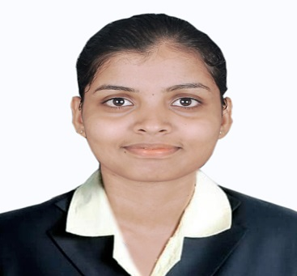

CAROLINE

Visa Status: Visit Visa
Valid up to: 17 Oct 2017
DATE OF BIRTH: 26/02/1994

MARITAL STATUS: SINGLE

CAROLINE.371455@2freemail.com

___________________________________________________
To work for the betterment of the organization, by contributing the knowledge and interpersonal skills acquired and believe to achieve quick and steady growth from career perspective.
________________________________________________________

WORK EXPERIENCE IN INDIA

SHARATH TECHNOLOGIES PVT. LTD – BANGALORE (2016 - 2017)
DESIGNATION: QUALITY CONTROL
- Develop and submit PPAP documents for new product launches to meet customer requirements.
- Develop and submit 4Q reports for the customer complaint.
- Resolve quality issues of capability, tolerance and material related issues.
- Resolve quality issues by identifying problems, examining solution options, implementing action plans and providing resources.
- Co-ordinate with sales, purchasing, engineering, production to resolve customer complaint and concerns.

PROFICIENCY
LANGUAGE KNOWN:

SPEAK / READ / WRITE | SPEAK
ENGLISH/ HINDI/KANNADA | TULU / KONKANI

COMPUTER LITARACY:
- Programming Languages: Core java, basics of C, HTML.
- J2EE Technologies: JDBC, Servlet .
- Operating system: windows 7/8,fedora.
- Application packages: MS office(Word,Excel)
- Tools used: Turbo c/c++, Eclipse
- Internet Browsing Skill and Email Skill
- Typing Speed : 30 WPM
- Key Skills:
- Ability to work independently as well as in a team.
- Quick adaptability to changing circumstances.
- Honest and punctual.
- Good communication skill
- Self-motivated.
PROJECT:
- Name of the Project: Ticketing system of Indian Railways through SMS and swapping machine.
- Description: The solution of the problem related in consumption of time and insufficient cash available at the time of ticketing, alternative mode of payment other than specified by the Indian railways while taking a ticket from the ticket counters.
- Roles and Responsibilities: Design, coding and documentation
- Operating System: Windows
- Front End: Java
- Tool Used: Eclipse

TRAINING AND CERTIFICATION:

- Completed Java Course at JSpider Institute, Bangalore.

ACADEMIC RECORDS:
Qualification | University/ Board | College / School | Year | Result
B.E(IS) | VTU | P.A.CE | 2015 | 63.48%
PUC | KSB | ST.MARY’s  COLLEGE | 2011 | 57.83%
SSLC | KSB | ST. FRANCIS COLLEGE | 2009 | 69.92%

DECLARATION:

I hereby declare that the above details are true to the best of my knowledge, information and belief.

