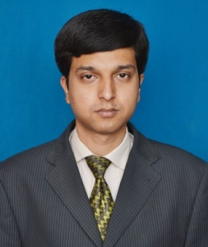
Curriculum Vitae

FARAN

FARAN.371462@2freemail.com
OBJECTIVE:

Looking for a challenging career, where there is a scope for demonstration, always on a look out for a positive and bigger outlook. I am willing to give my total support to the organization that I am in, with the experience and capability that I have, in order to achieve the organization’s goals and objectives and create mutual benefit.
EDUCATION RECORD:

- Matriculation:
S.S.C 1st Div (2003) Gujranwala Board
- Intermediate:
F.A 2nd Div (2006) Gujranwala Board
- Graduation:
B.Com 2nd Div (2008) Gujrat University
- Master Program:
MBA (HR) (2011) Federal Urdu University of Art, Science & Technology

EXPERIENCE:
E:

- 1.5 Year experience as a shift manager in Mcdonald’s River Jhelum where I have to perform a variety of tasks, which may include planning for each shift, monitoring performance during the shift, taking action to ensure the team is meeting McDonald’s standards, monitoring safety, security, and profitability, and communicating with the next Shift Manager to help prepare him/her to run a great shift, too. As a Shift Managers I am also responsible for meeting targets during their shifts and for helping their assigned Departments meet their goals.
- As a Shift Manager, I am responsible for:
- Food Safety
- Internal Communication
- Inventory Management
- Daily Maintenance and Cleanliness
- Managing Crew
- Quality Food Production
- Exceptional Customer Service
- Safety and Security
- Scheduling
- Crew Training & Development

- I have two years experience in Mobile Software at Hamza Mobile Center shop my responsibilities are repairing the damaged software of all brands mobiles and unlocking country codes of cell phones of any brand, relocking the cell phones, Games, media & applications installation in cell phones etc.

- I have Ten months experience of Cash Sorting in Bank Alfalah Islamic IBG Sarai Alamgir. Where I sort cash on daily wages and help teller in cash balancing & closing and learn about cash posting in “T24 Core banking software” from teller. I am also leans to work as DMS Backup Officer in Bank Alfalah Islamic IBG Sarai Alamgir.

- Active Citizen Certificate for attending training program of Active Citizen CPDI British Council.

COMPUTER SKILL:
:
E:
- Proficient in operating Ms Office, In-page, Adobe Photoshop, Coral Draw.
- Internet Surfing (Mailing, Web Browsing, Web Searching etc.)

AIM OF MY LIFE:

- To work hard with endless struggle for the promotion of my abilities
- To serve people with sacrificing my own benefits

LANGUAGES:

- English ……. Average
- Urdu ….…. Fluent

REFERENCES:

I certify that the above information is true and accurate to the best of my knowledge. Reference can be furnished if demanded.

