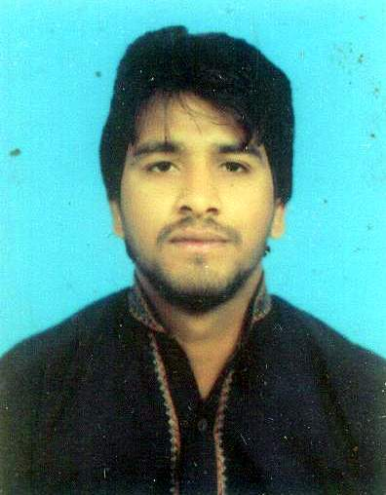
MUHAMMAD.371488@2freemail.com

Muhammad

MISSION STATEMENT
I am seeking a challenging career that utilizes my skills in concern area of competence and enhance my knowledge. An organization which provides me opportunities to perform my duties fully, which contribute towards growth and progress and provides me job satisfaction and enhance professionalism.
QUALIFICATION

- M. Phil Agriculture CGPA 3.39/4.00
Major: Agronomy Session: 2014-2016
University of Agriculture Faisalabad, Pakistan
- B.Sc. (HONS.) Agriculture CGPA 3.35/4.00
Major: Agronomy Session: 2010-2014
Islamia University of Bahawalpur, Pakistan

- F.Sc. (Pre-medical) Marks 766/1100
B.I.S.E Faisalabad Session: 2008-2009

- Metric (Science) Marks: 586/850
B.I.S.E Faisalabad Session: 2005-2007

EXPERIENCE
(01-02-2014 to 01-05-2014) INTERNEE
- 90 Days Internship in Wheat Program, Fiber Crop Section, Ayub Agriculture Research Institute, Faisalabad.
(Project Title: Relay Cropping of Wheat in Standing Cotton V/S Conventional Tillage of Wheat after Cotton)

(15-08-2015 till continue…) TEACHING
- Working as ESE(Sci­Maths) at Govt. Elementary School 347 G.B. Tehsil and District Toba Tek Singh, Punjab, Pakistan.

- Good written and verbal presentation skills.
- Taking responsibility for one’s messages.
- Ability to share one’s thoughts.
- Ability to plan, organize and schedule the activities of staff.
- Experience assigning, delegating and directing the work of others.
- Ability to work with people and work under stress.
- Best teaching skills.
- Research management.
- Public relations.
- Good command of Microsoft Office™ tools (Word, Excel & Power Point).
- Can operate WindowXp, Vista, 7 & 8 + Installation.
- Internet Surfing.
- Cricket
- Football
- Drawing
- Reading books

Communication Skill

Organizational Skills
Job-related Skills

Computer Skills

Other Skills

REFERENCES
Reference will be furnished on demand.

