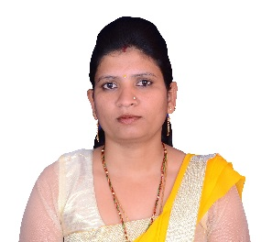
TEENA
Teena.371516@2freemail.com

Profile
Committed Hindi Teacher with a diverse ability to teach Hindi in public and private schools. Adept at including important cultural elements into prepared lessons. Specialize in tracking students' progress and setting attainable goals.

Highlights
- Strong grasp of current Hindi teaching practices
- Extensive personal experience with the Hindi culture
- Ability to select appropriate classroom materials
- Extraordinary language teaching abilities
- Remarkable written and verbal communications skills
- Fluent in Hindi and basic in English

Education Qualification
Academic Qualification : B.Ed. in Hindi from University of Jammu (2010)
: Master of Arts from University of Rajasthan (2013)
: Bachelor of Arts from University of Rajasthan (2009)
: Higher senior secondary from Rajasthan Board (2006)
: Secondary school from Rajasthan Board (2003)

Other Qualification : RS-CIT (Rajasthan State Certificate in Information Technology)
: Certificate in NCC

Professional Experience
HINDI TEACHER July/2014 – January/2016
Mahatma Jyotiba Phule Senior Secondary School Maharkala, INDIA
- Set up classroom debates and oral presentations to encourage use of language skills.
- Prepared tests and quizzes to track progress and provided individual feedback.
- Prepared classroom lectures and engaging activities to encourage participation.
- Arranged special classroom sessions to introduce students to Hindi culture.
- Assessed students individually and as a group to determine comprehension
- Ensured that all of the district's curriculum guidelines were followed

HINDI TEACHER December/2010 – January/2014
Vishnu Vidhya Niketan Jaipur, INDIA
- Provided daily feedback to students in the tutoring program and recognized progress.
- Selected the appropriate tutoring programs and materials for each student.
- Participated in periodic trainings and conferences to keep skills up-to-date.
- Evaluated student needs and employed appropriate techniques to teach Hindi.
- Scheduled regular meetings between parents and students to track progress.
- Put together customized PowerPoint presentations to illustrate concepts.
- Maintained effective communications with students and parents

I.T Skill
Basic knowledge of computer i.e. MS Word, MS-Excel, Internet

Personal Dossier
Date of Birth : 08 July 1989
Gender : Female
Nationality : Indian
Languages Known : Hindi, Basic English
Marital Status : Married
Visa Status : Tourist Visa

I, the undersigned, certify that to the best of my knowledge and belief, this CV correctly describes my qualifications, my experience and me.

Teena
Abu Dhabi

