Ganesh
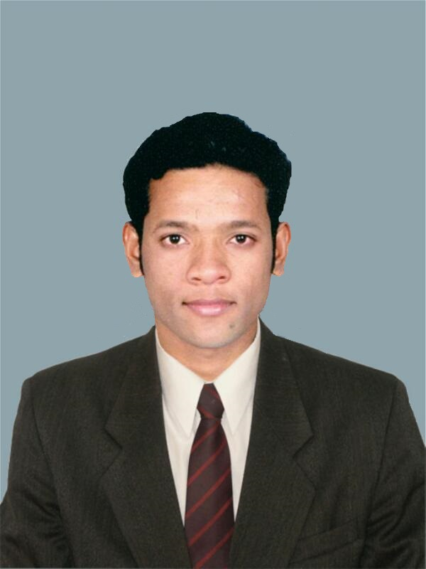
Ganesh.371540@2freemail.com
MBA Finance-BE Computers
To proactively nurture the business of my organization by working as an Analyst / Trader in various commodity market segments by utilizing financial and technical domain knowledge and performing consistently for positive outcomes in continuously changing business environment thereby creating a good wealth and superior Client base for the Company.
KEY SKILLS  Exchange based trading – Commodity and Currency Derivatives Market  OTC Derivatives Products  Technical Analysis of Charts with Charting Techniques  Analytical Skills  Business Analysis  Documentation Skills  Windows- XP/7/8, MS Office, Excel  KEY STRENGTHs  Ability to easily get acquainted with Diversified Business Environments  Good Planner and Strategist  Proactive Leaner and Good Listener  Self Discipline  key interests  Base Metals & Crude oil Trading  Learning about Physical Commodities Market  Fitness Activities  Reading  CERTIFICATIONS  Certified NCFM – Capital Market Dealers Module  Monster India Certified – Level 1 Web Technologist  Pathfinders Institute – Stock, Commodity & FOREX Traders Training |  |  | CAREER HIGHLIGHTS  Assistant manager – International commodity trading at Aster Commodities DMCC an Edelweiss Group Company, Dubai, UAE ▪ AUG 2015 to Present  - Managing the analysis & execution of trades on various exchanges and negotiation of deals with OTC brokers for commodity & currency trades  - Implementing Corporate Trading Strategies  - Trading variety of investment vehicles including Commodity futures- Base Metals & Energy Products, Currency Futures & Forwards, Base Metals Options on LME, NYMEX, CME, DGCX, MCX, NSE, BSE & Other OTC banks  - Providing calls based on Fundamental analysis, Technical analysis and Market events, for Commodities and Currency Pairs  - To assist in developing products based on Commodity and Currency trading vehicles  - Co-ordination with Legal, Compliance and Risk teams to ensure that all regulatory requirements are followed correctly  - Creating complex Excel files for smoothening of trading operations and risk minimization  - Handling complete Documentation part for New Product Development, New Strategy release, Process flowchart and presenting it to higher level of management  - Collaborating with management and trading teams to conceptualize goals, build strategic plans and implement processes to achieve targets  ASSOCIATE- OTC DERIVATIVES at SS&C GlobeOp Financial Services Technologies (India) Pvt. Ltd, Mumbai, India ▪ FEB 2014 to JUL 2015  - Experienced in Hedge Fund Administration services on OTC Derivatives Products- CDS, IRS, EQS, FXO, CCS  - Reconciliation of Trade Economics between Geneva s/w and counterparty / Prime Broker Statements  - Identifying risks and breaks involved in Trade Positions with the help of MARKITWIRE / DTCC Platforms / Tpty systems  - Interacting proactively with Clients and Counterparties /UK-US colleagues on day to day basis for resolving issues  - Hands on EMIR Trade Reporting  - Working on UAT for various projects on Geneva Development  MANAGEMENT TRAINEE at State Bank Of India, BKC Mumbai (HO), India ▪ MAY 2013 to JULY 2013 ▪ Summer Internship  - Understanding the concept of CLUSTER in Business and Opportunities available for it  - Visiting and identifying Business Requirements and Resources available for Cluster in Rural Area of Maharashtra, India  - Analyzing and developing a Financial Plan for Business  - Presenting Business / Financial blueprints to Higher Management at Bank and getting loan approval for it  KEY PROJECTS  - Idea generation and Trade Initiation of Base Metal’s Physical Trade at Aster Commodities DMCC  - Conducting “Awareness and Training Programs” for Business Development & Financial Literacy of Tribal Warli Artists at rural regions of India for 2 months  - Trend Analysis & Ratio Analysis of Indian Companies  - Designing of Autonomous Artistic Robot- IIT Bombay  ACHIeVEMENTS  - Higher Management Appreciation for creating an OTC process flowcharts and guides for new hires  - B.E. final year Project completion under direct supervision of IIT Bombay  - Computer Departmental Topper Award in B.E. during final year  - 10th Ranker from Greater Mumbai in Navhind Dyanpeeth - Mathematics -2005

Master of Management Studies (MMS)/ MBA from Vivekanand Education Society’s Institute of Management Studies & Research, Mumbai University, 2014
Specialization & Grade – Finance / Distinction

Bachelor of Engineering (BE) from K.C. College of Engineering, Mumbai University, 2012
Specialization & Grade – Computer Science/ Distinction

HSC from K.J. Somaiya College of Science & Commerce, Maharashtra State Board, 2008
Specialization & Grade – Science/ Distinction

SSC from PVG’s Vidya Bhavan, Maharashtra State Board, 2006
Specialization & Grade – Science/ Distinction

Personal Information:
Date of Birth – 27 March 1991 (26 years) Gender – Male
Nationality – Indian
Marital Status – Married
Visa Status – Company Sponsored Residence Visa (Start Date – 25 August 2015)
Driving License – Valid UAE driving license
Place: Dubai, UAE Date:

