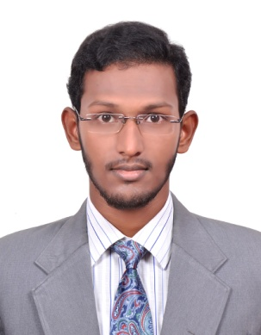
CURRICULUM VITAE

M. ASRATH B.TECH (IT)

[Email]

ASRATH.371545@2freemail.com

objectives |  | To work in a company with professional work driven environment where I can utilize and apply my knowledge, skills which would enable me as a experienced candidate to grow while fulfilling organizational goals.
Profile |  | A Focused software developer with experience in developer position by variety of technologies java and PL/SQL and Having hands on experience on database connectivity, I am a candidate to work under pressure, team work oriented, capability to find the solution for the problem in short span of time and a keen eye for detail results in solid coding and trustworthy software programs.
Technical skills |  | Programming languages  C, Java, PL/SQL  Database  oracle,  markup language  HTML,  Operating System  Windows XP, Windows 7,Windows 2008,8.1
Education |  | Kings College Of Engineering – Thanjavur - B.Tech (IT)  2016 62.6%  Maxwell Matriculation higher secondary School - Thanjavur - HSC  2012 59.5%  st. bastin’s matriculation school - Papanasam - SSLC  2010 71.8%
ACHEIVEMENTS | 1 | Have organized and played a zeal role in every symposium conducted in my College  Winner in District level football.  Awarded Divisional level participant certificate in Athletics (High Jump)
ipT and Training |  | International Workshop on Android Application Development-IWAAD’14  IPT at HCL Technologies (Time concept of Software and Networking)
ACADEMIC PROJECT |  | Project Title: Detection and Rectification of Distorted Finger Prints  Project Domain: Image Processing  Project Description:  Finger print of a person identified accurately without any mismatch, Even that particular persons finger prints get distorted, It is identified easily by using modules. It consist of three modules which is Identified the right person by comparing with stored finger print from the Database.
EXPERIENCE |  | Software Developer,  First Source,  India,  May 2016 to still working,

Personal detail
NATIONALITY : Indian,
DATE OF BIRTH : 06/06/1995
GENDER : Male,
MARITAL STATUS : Single,
LANGUAGES : English, Urdu, Tamil,

declaration

I hereby assure you that the above furnished information are true to my knowledge,

I would work for the mutual betterment of the firm as well as self in all possible aspects.

