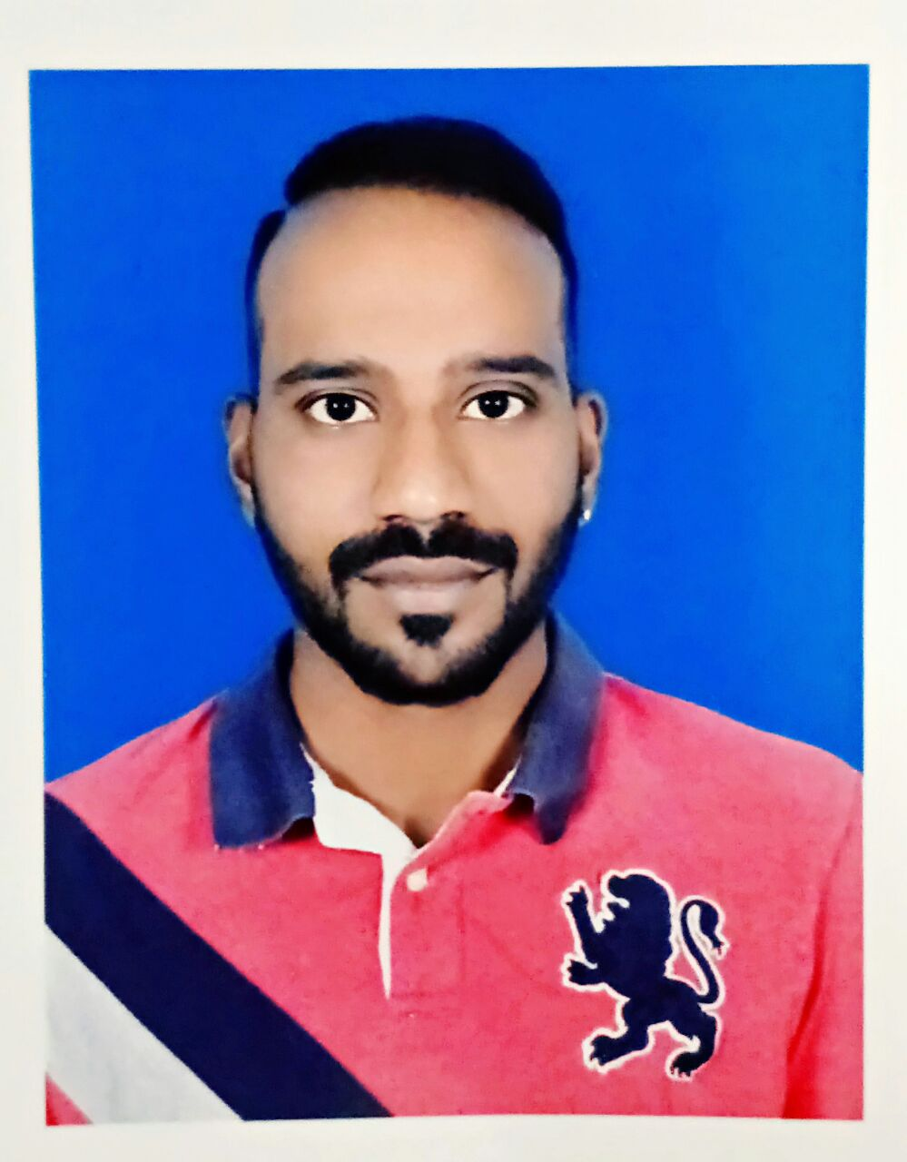

Karthik
Karthik.371546@2freemail.com
A dedicated professional with integrated set of competencies that encompass areas related to Quality Control & Assurance
Industry Preference: Woodworking / Interior Fit out

Profile Summary
- Result-oriented professional with over 6 years of experience (including 3 years in Quality Control and Quality System Management)
- Competent in Quality System Development:
- Q.C Management
- Quality
- Effort & Time Estimation
- Manpower Management
- Team Meetings for Q.A & Q.C Analysis
- Time Management
- Successfully managed multiple projects such as:
- Saudi Hotel (Saudi Arabia)
- Millenium Hotel (Muscat)
- Panorama Mall (Muscat)
- Al-Habib Constructions (Muscat)
- Anantara spa & Resort (Al jabal al akthar, Oman) & so on
- Trained all employees in new requirements of ISO: 9001-2015 Quality Management system
- Pivotal in developing quality baselines, monitoring & controlling quality standards from initial stage to product delivery, resource deployment, time overruns and quality compliance to ensure satisfactory product delivery
- Excellent communication, team management, analytical study & Problem diagnosis skills.

Skill Set
Presenter
Planner
Motivator
Communicator
Collaborator
Academic Details
- B.B.M. from Gayathr Vidya Parishad, Vishakhapatnam in 2009
- 12th Class Secondary Education from Sri Chaitanya College, Vishakhapatnam in 2006
- 10th Board Education from Sri Prakash Educational Institutions, Vishakhapatnam in 2004

Core Competencies
Regulatory Compliance | Material Management | Resource Allocation /Optimization
Training & Development | Sample Preparation | Reporting & Documentation
Time Management | Statistical process control | ISO Audit Preparation & Documentation

Major Projects  At Global Wood Work LLC, Sohar (Oman)  - Shaza Hotel (Muscat)  - Abcon Towers (Muscat)  - Shaksy Engg. (Muscat)  - Royal Office (Gubra, Muscat)  - Saudi Hotel (Saudi Arabia)  - Al-Habib Constructions (Muscat)  - Millennium Hotel (Muscat)  - Panorama Mall (Muscat)  - Dawood Contraction (Muscat)  - Samad Al Qureshi (Muscat, Ibri & Buraimi)  - Intenational marble company ( Muscat, Ibri – Oman)  - Anantara spa & resort (al jabal al akthar-Oman)  - Special task force-dawood contracting (suwaiq, oman)  - Adam air base (Adam, Oman)  - Teejan rop (Bahja, saiharawl, dimawatheen, wadi bin khalid – Oman)  - Saraya bandhar jissha (Muscat, Oman)  - Paci carillion (Muscat, Oman)  - Osco-rop hospital (Muscat, Oman)  At ANR Group  - Splendid Arcades  - Hermitage Apartments  - Vasthu INN  - Smart INN  IT SKILLS  Operating System: Windows  Tools: MS Office(Word/ Excel/ PowerPoint)  Technical: AUTOCAD | Organizational Experience  Since Nov’14 with Global Wood Work LLC, Sohar (Oman) as Q.A / Q.C Engineer  Jan’10–Aug’14 with ANR Group, Vishakhapatnam (India) as Marketing Executive  Key Result Areas:  - Leading weekly Quality Progress review meetings and identifying bottlenecks / hold-points; implementing modifications and improvements in completion of quality product.  - Managing different functions engaged in procurement operations; accessing  - Communicating with project managers to understand quality standards maintenance & reports; coordinating with factory & site staff , designers & contractors for development of present procedures  - Validation of Process, Machinery, Methods Etc...  - Minimization of rejection & rework  - Develop & Implement Quality management strategy & plans  - Quality Assurance for the projects & manufacturing set up  - Evaluation of new suppliers & vendors  - Establish Quality standards & implementing quality control requirements of the customers and handle compliant.  - Standardization for goods & works inspection.  - Conduction training for employees on quality system & procedures  - Providing support to production & administrative staff  Highlights:  - Played a key role in implementing quality norms and analysis for the production activities as per the system that ensured best product delivery.  - Analyzed quality problems and diagnosed problems for ensuring on-time completion of production with best quality.  - Merit of receiving Best Employee for Forest stewardship council (F.S.C) Audit in 2017.  - Merit of receiving Best Employee for ISO9001-2015 Audit in 2017.  - Steered efforts in adding new quality procedures by Maintaining reports & Analysis of previous issues, Q.A/ Q.C Training & conducting technical team discussions before starting production.
Personal Details
Date of Birth: 10th June 1987
Languages Known: English, Telugu & Hindi

