Faizan
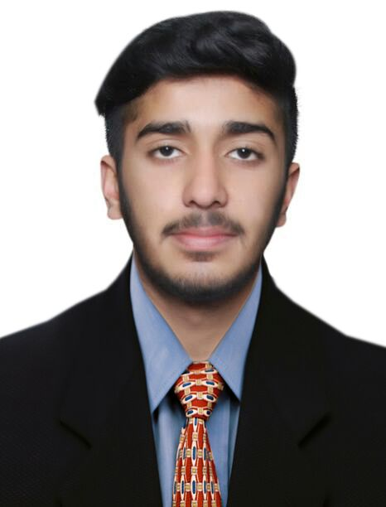
Faizan.371547@2freemail.com

An outgoing, loyal and dedicated individual who has an ambition to succeed in any given environment. I have superb ability to prioritize, multi-task effectively, and a commitment to quality performance with an ability to learn new procedures quickly.Thorough knowledge of reservation systems and transactions processing, including Sabre, Galileo and other on-line engines.

WORK EXPERIENCE

Sales Executive
Travel 24/7 - Sialkot - January 2016 to June 2017

• Did internship at View National Travel (IATA)
• Eighteen months experience at TRAVEL 24/7

EDUCATION

BA ( Business Administration ) in Business
Virtual University of Pakistan - Sialkot
August 2016 to July 2018

F.Sc ( Faculty of Science ) in Pre-Engineering
Punjab Group of Colleges - Sialkot
September 2014 to July 2016

Matriculation in Pre-Biology Quaid-e-Millat Public School - Sialkot April 2012 to March 2014

SKILLS

Microsoft Office, GDS - Sabre, GDS - Galileo

CERTIFICATIONS/LICENSES

Air Ticketing & Tariff
October 2015 to Present

ADDITIONAL INFORMATION

• Excellent customer service skills and good organization skills.
• Able to work instinctively with good initiative.
• Strong communication skills and a good telephone manner.
• Ability to cope with pressure at busy times.
• Sales skills, both face to face and over the telephone..
• Motivated, Transparent and honest with my work
• Visa Type - Visit ( 12 Jul - 10 Aug )

