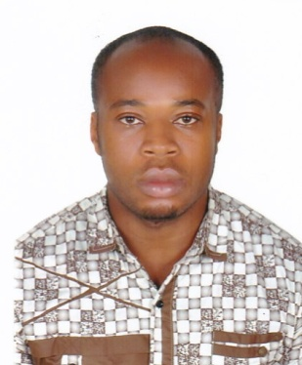
ONYEWUCHI
ONYEWUCHI.371551@2freemail.com

POST APPLYING FOR: COMPUTER TECHNICIAN
PERFORMANCE SUMMARY:
Dedicated and resourceful computer technician with 9+ years’ extensive experience in testing, installing, repairing and maintaining a diverse range of hardware, software and peripherals. Well versed in providing quality support and customer services maintaining a safe and responsible work environment.
PERSONAL DATA:
Date of Birth : 25th October, 1986
Sex : Male
Marital Status : Single
State of Origin : Imo
Nationality : Nigerian
Local Govt. Area : Mbaitoli
ACADEMIC QUALIFICATION WITH DATES:

- 2008 : Senior School Certificate Examination (NABTEB)
- 2003 : Certificate in Diploma in Networking and Communication
- 2001 : Diploma in Computer Maintenance and Hardware
- 1995 : First School Leaving Certificate (FSLC)
EDUCATIONAL INSTITUTIONS ATTENDED WITH DATES:
- 2002-2008 : Government Technical College Sch. Sec. Imo State.
- 2002-2003 : Ife-System Networking, Owerri Imo State.
- 2000-2001 : Institution of Computer and Allied Studies Imo State.
- 1995-2001 : Township School. Owerri Municipal

TECHNICAL EXPERTISE:
● Installation: All kinds of hardware (Branded and non-branded), windows, software, applications and antivirus
● Troubleshooting: Failure identification, desktop/laptop/printer break-fix, servers and workstations management
● Operating Systems: Windows, etc
● Computer Networks: LAN/WAN, Cabling

PROFESSIONAL EXPERIENCE:

- PC Technician |Ama-system Networking , Nigeria, Jan 2010- May 2016
- Worked as a helper Majelan Group of Companies, Fujairah, U.A.E 11 June 2016 to till now.

DUTIES AND RESPONSIBILITIES:
• Redesign and implement a more efficient network system resulting in optimal performance of all workstations.
• Troubleshoot an extremely challenging software problem with a standalone PC.
• Install hardware and software on standalone personal computers and laptops.
• Ensure maintenance of end user workstations and peripheral devices.
• Assist in providing desktop application solutions.
• Quickly respond to technical assistance requests.
• Manage testing procedures for newly installed hardware and software applications.
• Ensure timely repair of equipment.
• Assist with network troubleshooting procedures.
• Provide backup to the network administrator.
• Install and update antivirus programs on a constant basis.
PERSONAL PROFILE:
- Professional Computer Engineer with years of experience.
- Computer Engineer, System Network, Installation, Communication.
- Good communication skills.
- Ability to work under pressure.
- Ability to work with less supervision.
- Ability to work effectively.
- Good management, Analytical and communication skill.
HOBBIES:
- Internet Research
- Creative
- Travelling
- Meeting people and making good friends.

