NAZHA.371561@2freemail.com 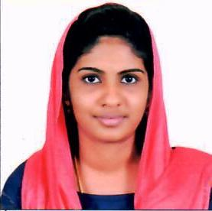

Career Objective:
Extensive knowledge and skills to teach Mathematics to Children. Dedicated to create a positive learning environment and make a difference in student’s lives by providing them better education skills.

Education:
2015 : MSc. Mathematics (University of Kerala. Karyavattom campus)
(With 73 % marks)
2013 : BSc. Mathematics (University of Kerala .The HH Maharajas Govt. college)

(With 82 % marks)

Area of Teaching:
- Algebra
- Analysis
- Number Theory etc.

Skills and Accomplishment:
- Talent for capturing student’s significance in education by providing them exercise, support and supervision.
- Identify student’s individualism and develop curriculum to accommodate special learning styles, maximizing student’s comprehension.
- Establish comfortable, student-focused, two way communication that empowered students to enjoy the learning process.
- Maintain productive learning environment by staling classroom rules, holding students accountable for their actions and implementing consistent and fair consequences.
- Provide informative management to students about different areas of studies.

Personal Profile:
- Sex Female
- Date Of Birth 31/08/1992
- Marital Status Married
- Languages Known English , Malayalam
- Nationality Indian

Declaration
I solemnly declare that the details given above are true and complete to the best of my knowledge and belief

