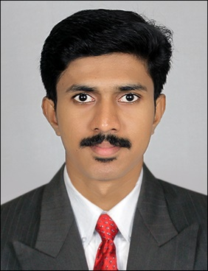
Vincent.371569@2freemail.com

Vincent

Career Objectives
To be an effective and active person in the organization with a sincere and positive mind that would be helpful in achieving the organizational goals as well as my career objectives.

Lines About Me
I am an enthusiastic and forward-looking person with excellent interpersonal and leadership skills. I consider myself as very flexible and adaptable. I am good at quick decision-making along with good analytical skills and also have great faith in God.

Professional Experience

- One-year experience with Kains Instruments India Pvt. Ltd, Bangalore as associate HR.
Responsibilities Handled
- Make the coordination with various departments of the company.
- Ensuring compliance by providing proficient guidance of state and federal laws.
- Preparing and maintaining various MIS Reports like Tracker sheet, Daily and weekly dashboards.
- Sourcing CVs from various channels such as referencing, company’s own database, Job Portals.
- Evaluating vendor performance
- Tracking attendance, maintaining leave records, PF records
- Present the employees performance report in front of HR manager.

Educational Qualification
Course | Year |  | Institution/University | Score
(H.R & Marketing) Master of Business Administration | 2016 |  | East West College of Management  (Bangalore University) | 67 %
B.Sc.  Physics Model II | 2014 |  | Nirmala College, Muvattupuzha  (M.G University) | 60 %
TTC | 2011 |  | St. George TTI Vazhakulam  (Kerala University) | 72 %
Intermediate | 2009 |  | V.H.S.E Thodupuzha | 67 %
Matriculation | 2007 |  | Infant Jesus HSS, Vazhakulam | 63 %
Academic Projects
- A Study On Sales Promotion Techniques with Respect to Digital Marketing at Numato Solutions Pvt. Ltd, Bangalore.
- A study on cybercrimes in India.
- Study of oscillators using operational amplifier.
Leadership Activities and Awards
- Volunteer secretary of National Service Scheme at Nirmala college Muvattupuzha during the period of 2012-2013.
- Association secretary of Physics Department at Nirmala college Muvattupuzha during the period of 2012
- Student coordinator of college day at Nirmala college Muvattupuzha. (2013)
- Editor of Physics Department Magazine at Nirmala College Muvattupuzha. (2013)
- Achieved 3rd prize for Yoga competition at Mahatma Gandhi University. (2014)
Computer Knowledge
OS: Windows10, 8, XP,
Packages: MS-Offices2016 , Libre Office 5.1
Hobbies and Interests
- Farming  - Surfing Internet |  | - Volleyball  - Sudoku Puzzle
Declaration
I hereby declare that all the information furnished above is true to the best of my knowledge and belief.

