Fathima
Fathima.371571@2freemail.com

Software Engineer

Personal Summary
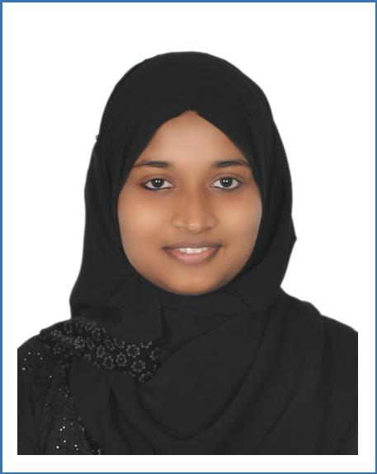

A flexible professional software graduate with a commitment to perform duties and experience of developing innovative and creative software solutions. Able to perform full software development life cycle activates.Have gained teaching experience during her academic years with exposure to software development. Including carrying out straightforward design, testing or support of network design and solutions following existing methodology set by senior colleagues. Actively looking for a software engineering position with a fast-paced and ambitious company that can oﬀer development, training, project based learning and mentoring programs.

 |  |  | Academic Snapshot
 | ²⁰¹³B.Tech Information Technology , MES College Of Engineering, Kuttippuram ,
 |  |  | Kerala, India.
 |  |  | CGPA 8.4.
2009 |  |  | HSC from Technical Higher Secondary School, Vattamkulam,Kerala, India,
• | 90.5%.
 |  |  | Passed with distinction
2007 |  |  | Senior Certificate, Technical Higher Secondary School, Vattamkulam,Kerala, India,
• | 84%.
 |  |  | Passed with distinction

Training and Certifications

{ Completed 3 months certification course MCSD(Microsoft certified Solution Developer).

{ Microsoft Certified Professional in “Developing ASP.NET MVC 4 Web Applica-tions” and Microsoft Certification ID (MC ID): 10767133

{ Had an industrial visit in “SwizcomSoftwares” as a part of Btech degree in 2012

Achievements

{ Fourth rank holder in B.Tech university exam { Attained GRE quantitative score of 156

{ Had scored Band 7 in IELTS held in september 2014

Career Summary

Higher Secondary School
2012-2014 Computer instructor in C++
{ Teach students in an eﬀective manner to advance their abilities.
{ Helped them in C++ projects and shared basic ideas of OOP and Java.

Royal Engineering College, Kerala
2013-2014 Guest Lecturer in CSE
{ Gained valuable technical experience and also developed teaching skills.
{ Sharing of knowledge helped to come over various types of views

 |  | Areas of Expertise
Languages |  | ASP.NET(C), Java script, JQuerry, C, C++, Python, Matlab
Web-based |  | MVC, AJAX, WCF, Web services, web parts, CSS(HTML),XML,XSLT, Basic knowl-
Techniques |  | edge in Share Point.
OS |  | Linux, Windows
Database |  | MySQL
Others |  | DBMS, Data structures, OOP, Microsoft Visual Studio 2008,2012

Projects Done

{ Worked out Image compression using Huﬀman coding

{ Developed the setup "TapIR-An intelligent reader" which made reading purposeful { Developed E-learning system for students

References

Available on request

Declaration

I hereby aﬃrm that the information provided here is fully true to the best of my knowledge.

