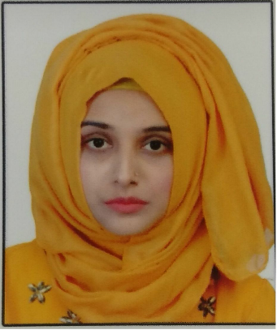
SAMAH
SAMAH.371582@2freemail.com
Confident and passionate person who loves
challenging situations and strives for excellence
through honesty, hard work and self-motivation.

EMPLOYMENT
SUPARCO | Assistant Manager | 2013-2016
Pakistan’s National Space Agency

I worked as Satellite Structures Design Engineer, working on iterative design algorithms which involve Mathematical modelling and sophisticated computation.
Conceptual design, 3D CAD modeling of harness and structural analysis on various parts of the satellite were some of the major tasks.

PAC, Kaamra | Internee | Jul-Aug, 2012
Pakistan Aeronautical Complex

At the end of freshman year, I was nominated for this 4 week internship opportunity. It was a great learning experience as we were allowed to visit various setups including engine overhaul shop, Boeing parts manufacturing unit, Plasma shop, and high precision CNC machines. I worked in the overhauling facility for various systems of the aircraft and rebuild facility of various parts of F-6 aircraft.

EDUCATION

Institute of Space Technology
Pakistan | www.ist.edu.pk
BSc Aerospace Engineering | 2009-2013
CGPA: 3.09 / 4.0

Matriculation/F.Sc
Pakistan | Federal Board (SSC/HSSC)
Grade A / Grade A1
2005-2009

ACHIEVEMENTS

BSc Aerospace (Pakistan)
5 year job contract awarded by SUPARCO along with fully sponsored undergraduate studies.

TECHNICAL EXPERTISE
Engineering and other software
- AutoCAD
- PATRAN-NASTRAN
- PRO-E
- MS office

OTHERS

Volunteer Work
- SOS International
- Akhuwat Foundation

Organizational
- Extracurricular Events Management.
- Startup of various bodies at university level including AIAA, and ASME.
- Fund raising activities for underprivileged children at university and personal level.

Personal
- Strong analytical skills
- Good communication and presentation skills

